Recently accessed records and worklists: a quick reference guide

## Introduction

### Purpose of the guide

This guide explains how to access the recently accessed records and worklists when directly logging onto the Shared Care Record using a user ID and password.

### Target audience

This guide is only relevant to users who access the Shared Care Record with login details. Unless you have been contacted by your organisation about this, please refer to the [single sign on training materials here.](https://www.midandsouthessex.ics.nhs.uk/work/digital-data-and-technology/shared-care-record/information-for-professionals/training-materials/)

### Prerequisites and requirements

User credentials are to be created prior to accessing the Shared Care Record.

***Please note that the record shown is a test patient and does not contain any personal identifiable information.***

## Recently accessed list

### The recently accessed list can be found on the left-hand menu when you log in to the Shared Care Record.

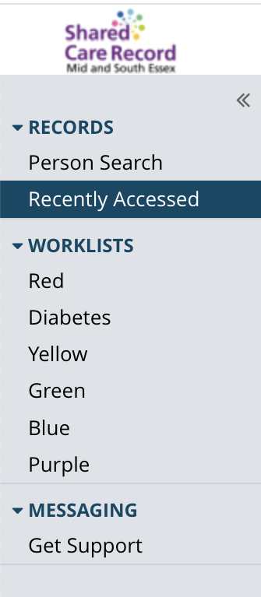

### Over time, your list of recently accessed records will grow. Information will be presented in specific timeframes of today, last 7 days, last 4 weeks and last 12 months.

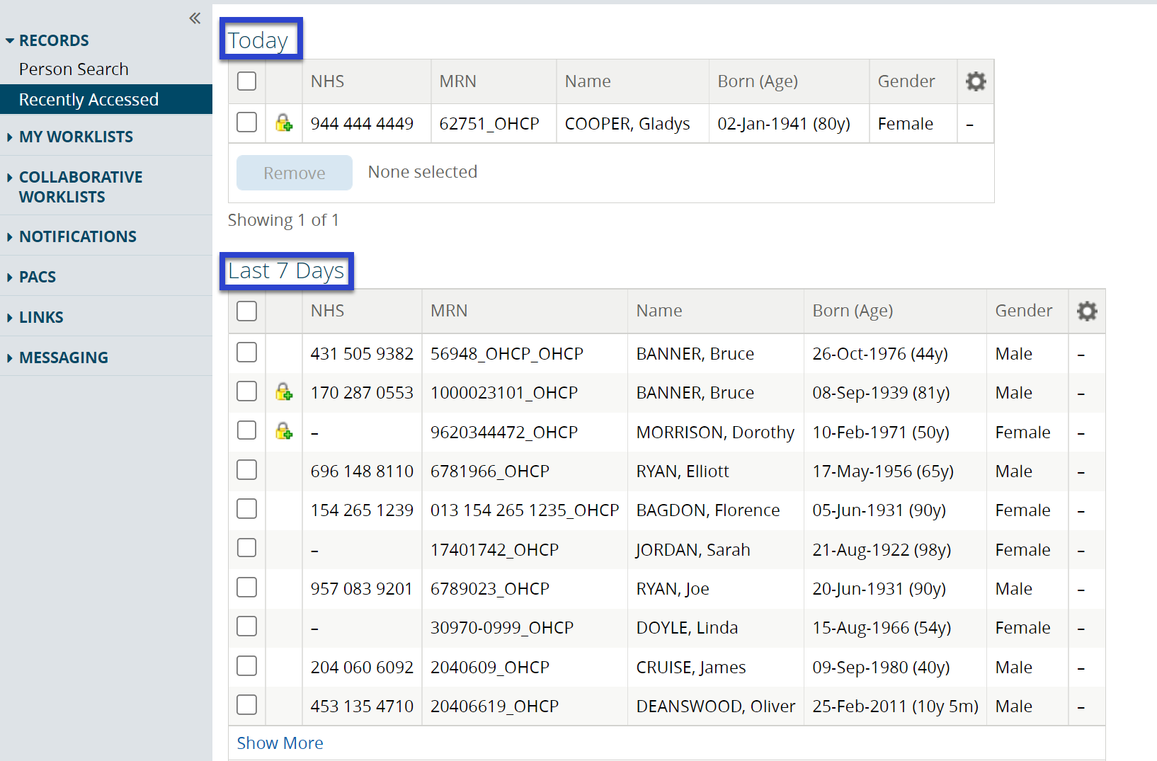

## Remove people from recently accessed lists

### There are two ways in which to remove people from the list of recently accessed records.

### If you would like to remove several records from a specific period, for example the last 12 months, select the checkbox to remove all and then select the remove button:

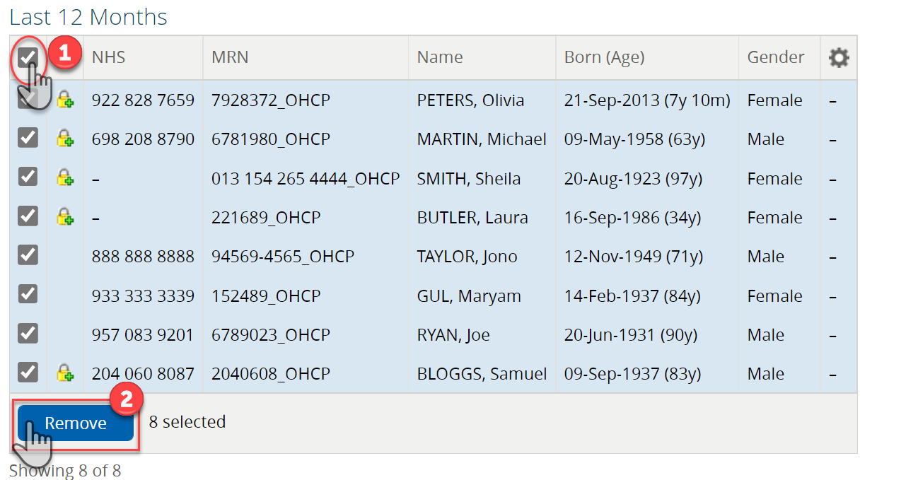

### If you would like to remove individual records from the list, select the checkbox next to the record(s) you would like to remove and then select the remove button.

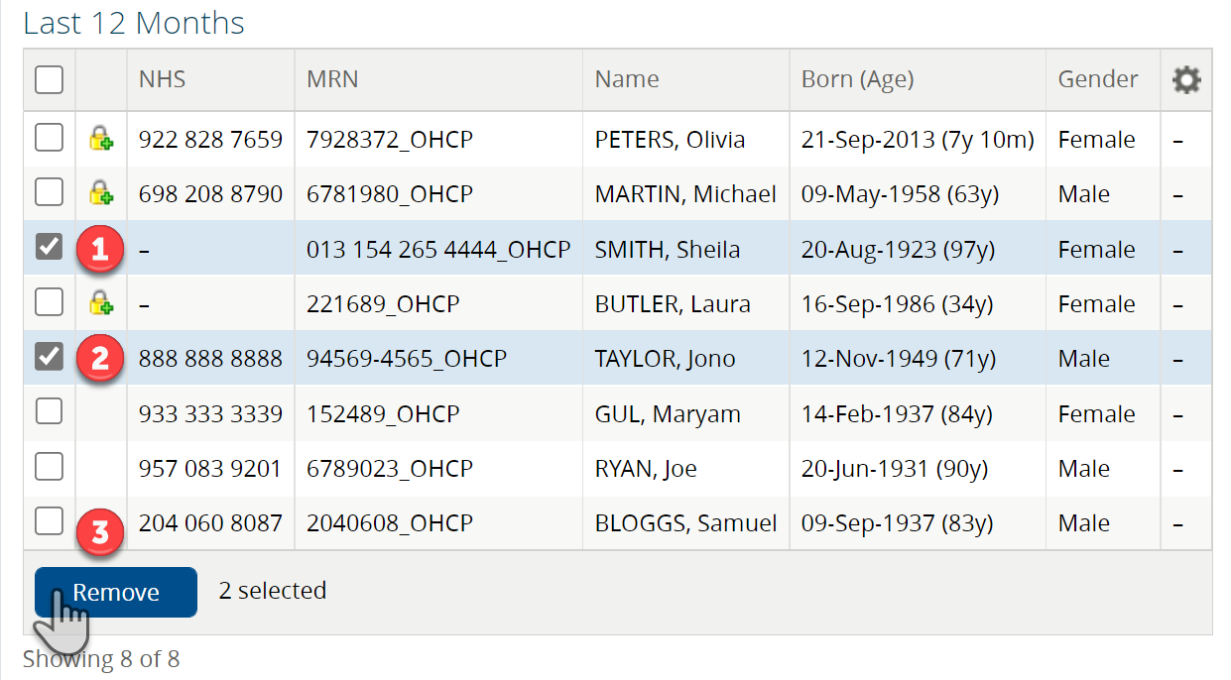

## Worklists

### Worklists can be accessed via the left-hand menu by selecting the WORKLISTS menu item. The default naming convention for worklists is based on colours.

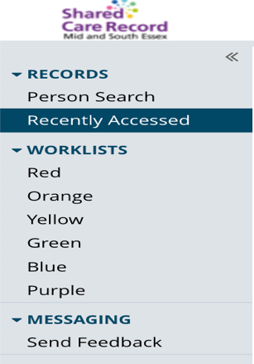

### To rename a list to something more relevant, select the list you would like to rename and then select the rename button.

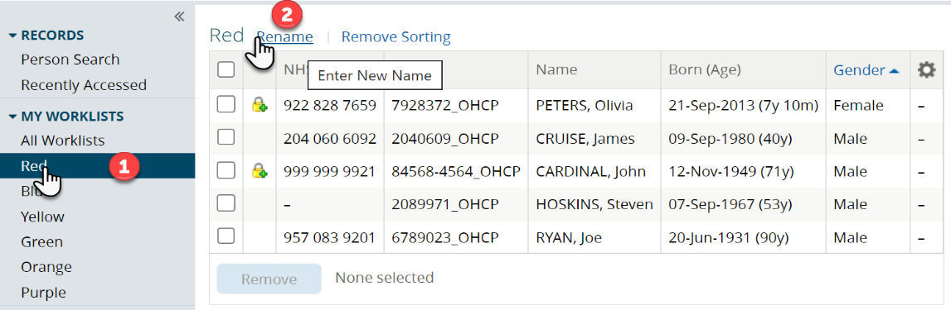

### Enter a name for the list and select save.

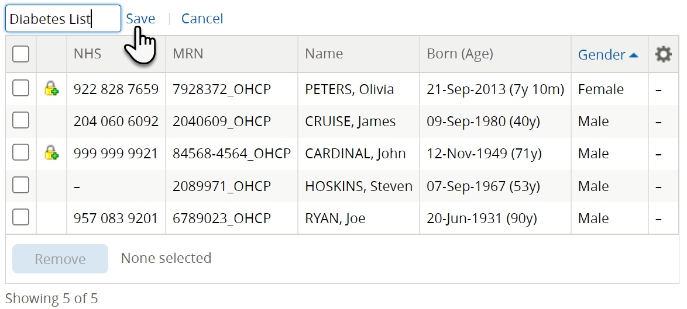

### You will notice the name change when you log back in.

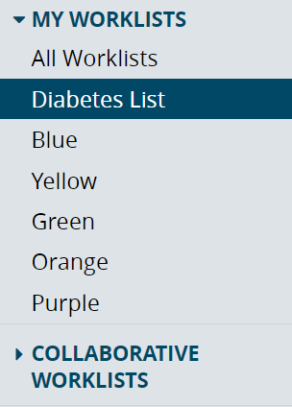

## Add a person to a worklist

### Search for a person and open their record.

### Select the + from the top left-hand side of the persons banner and then select the worklist you would like to add them to from the list.

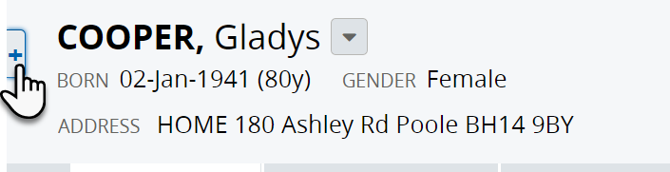

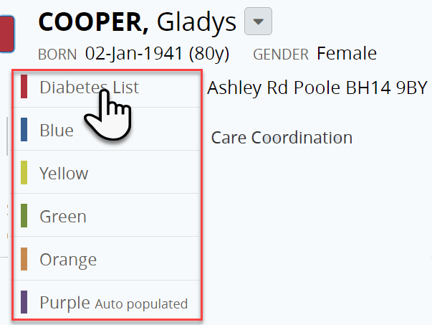

### The person will now appear on your worklist.

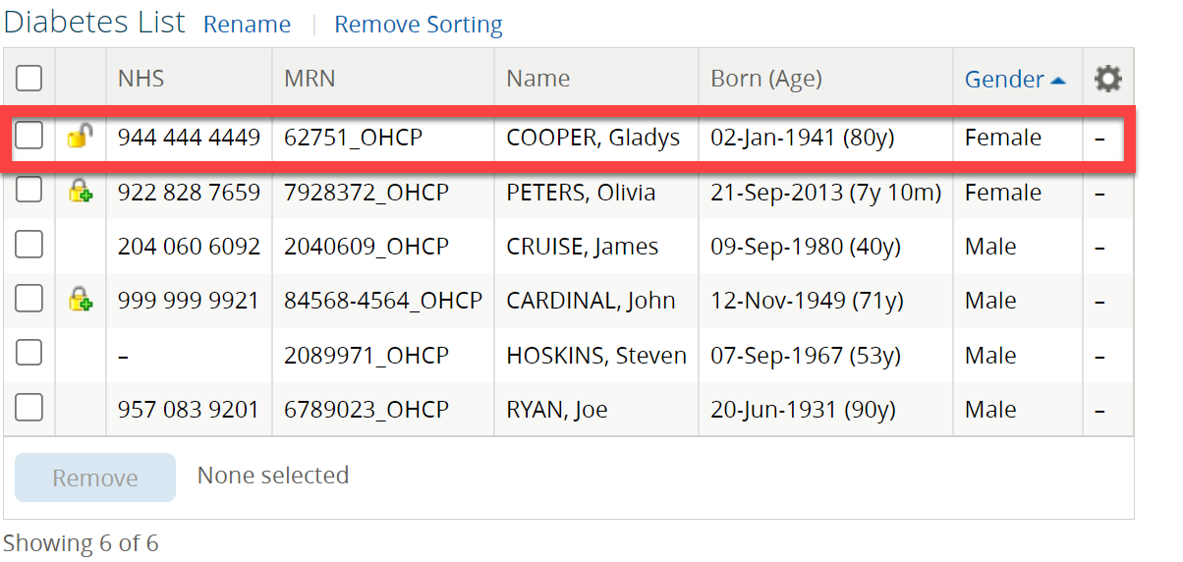

## Additional resources

* **Further information:** <https://midandsouthessex.ics.nhs.uk/sharedcarerecord>
* **Contact information for feedback:** [mse.sharedcarerecord@nhs.net](mailto:mse.sharedcarerecord@nhs.net)