Launching the Cerner Health Information Exchange from the Shared Care Record: a quick reference guide

## Introduction

### Purpose of the guide

### This guide explains how to access and navigate the Cerner Health Information Exchange (HIE) from the Shared Care Record.

### Target audience

Anyone who uses the Shared Care Record.

### Prerequisites and requirements

Access to Shared Care Record with an individual’s record open.

***Please note that the record shown is a test patient and does not contain any personal identifiable information.***

## Step-by-step instructions

### Load an individual’s record in the Shared Care Record.

### Select the Launch Cerner (HIE) option next to the summary tab.

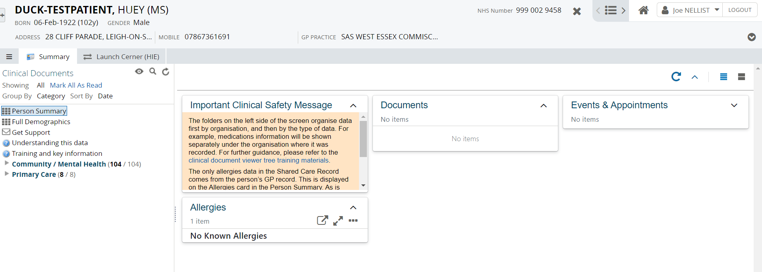

### The Suffolk and North East Essex Cerner Health Information Exchange (HIE) system is launched for the patient in context.

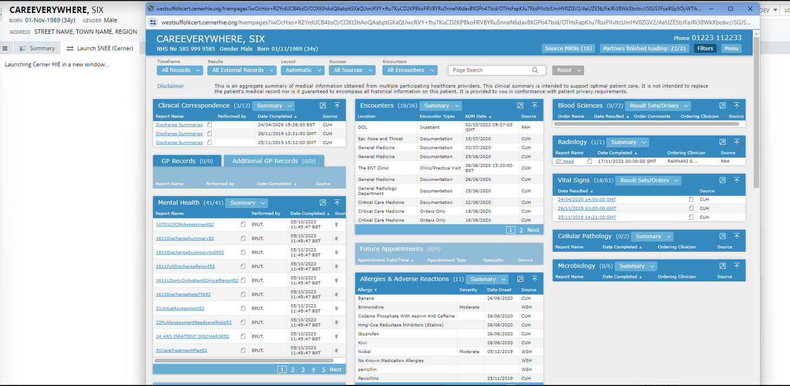

## Session expiration

The Cerner HIE opens in a new browser window. To safeguard patient data and ensure the highest level of security, activity in this new window is not monitored by the MSE Shared Care Record.

To further protect patient information, the MSE Shared Care Record system will automatically timeout after 5 minutes of inactivity. You can maintain your session by periodically returning to the MSE Shared Care Record window to refresh it.

If your session in the MSE Shared Care Record times out, simply reopen the individual's record from your clinical system to continue accessing the information securely.

## Training and support

### For information about this system, including what data is being shared by which organisation, please visit <https://www.sneeics.org.uk/can-do-health-and-care/creative/digital-data-and-technology/shared-care-record/>

### For training materials to support you to use the Cerner HIE system, please visit <https://www.hertsandwestessex.ics.nhs.uk/health-care-professionals/shared-care-record-information-for-professionals/shared-care-record-user-training-resources/>

## Additional resources

* **Further information:** <https://midandsouthessex.ics.nhs.uk/sharedcarerecord>
* **Contact information for feedback:** [mse.sharedcarerecord@nhs.net](mailto:mse.sharedcarerecord@nhs.net)