Health Inequalities Information Statement - Annual report 2023/24

# Document Control:

Date: 24/07/24  
Version: v1.1

# Contents

Health Inequalities Information Statement background 3

Health Inequalities reporting in MSE 3

MSE population 5

Population structures in Basildon and Brentwood 5

Population structures in Mid Essex 6

Population structures in South East Essex 7

Population structures in Thurrock 7

2021 Census ethnicity data 8

(Healthy) Life Expectancy in MSE 9

Inequality in Life Expectancy in MSE 10

Mortality attributable to socioeconomic inequality 11

Health inequalities governance in MSE 12

Mortality MSE has adopted the NHS Core20PLUS frameworks 13

Addressing health inequalities in everything we do 16

Working with our most deprived communities – CORE20 16

PLUS groups 18

5 Clinical Priorities - Adults 18

5 Clinical Priorities - Children and Young People 19

Planning priorities 2023/24 – Health inequalities 20

Health inequalities Funding 21

Health inequalities Indicators 2023/24 23

Domain: Elective Recovery 23

Domain: Respiratory 27

Domain: Mental Health 30

Domain: Cancer 39

Domain: Cardiovascular disease 40

Domain: Diabetes 52

Domain: Smoking Cessation 58

Domain: Oral Health 59

Domain: Learning disability and autistic people 61

Domain: Maternity and neonatal 66

## Health Inequalities Information Statement background

* Tackling inequalities in outcomes, experience and access is one of the four key purposes of ICSs.
* In November 2023 NHSE published new guidance on how NHS bodies discharge their responsibility to report information on health inequalities

[NHS England » NHS England’s statement on information on health inequalities (duty under section 13SA of the National Health Service Act 2006)](https://www.england.nhs.uk/long-read/nhs-englands-statement-on-information-on-health-inequalities-duty/)

* The guidance reflects a proportionate and phased approach to gathering and making use of available information on health inequalities and that this will evolve over time.
* NHSE provided list of indicators that NHS bodies should collect, analyse, and publish on health inequalities.

[NHS England’s Statement on Information on Health Inequalities (duty under section 13SA of the National Health Service Act 2006)](https://www.england.nhs.uk/wp-content/uploads/2023/11/PR2128-i-nhs-englands-statement-on-information-on-health-inequalities.pdf)

* MSE ICB’s annual report sets out how it meets its legal duty regarding the need to reduce health inequalities that includes:
  + Taking a population health improvement approach to understanding health needs and designing interventions that reduce health inequalities.
  + Utilising the Core20plus5 frameworks to target and prioritise resources for the greatest impact.
* This Health inequalities information statement is supplementary to the MSE ICB annual report and together provides MSE position against the NHSE guidance.
* MSE reporting on health inequalities will continue to develop in maturity.

## Health Inequalities reporting in MSE

MSE ICB working with its partners in public health and Arden & GEM CSU to strengthen its use of business intelligence to understand and respond to population needs through use of:

* Local Authority Joint Strategic Needs Assessments
* Integrated health and social care data and its expansion to include other socioeconomic factors such as housing data.
* Population segmentation tool that provides insights at Alliance, PCN and Practice level
* Core20plus5 Alliance and PCN packs to inform priority setting and opportunities.
* Health Inequalities dashboard in development
* Reports developed with standard Health Inequalities functionality enabling review by deprivation, ethnicity, sex, and age.
* Health Inequalities Impact Assessments and development of digital Impact EQ for use across health providers in MSE

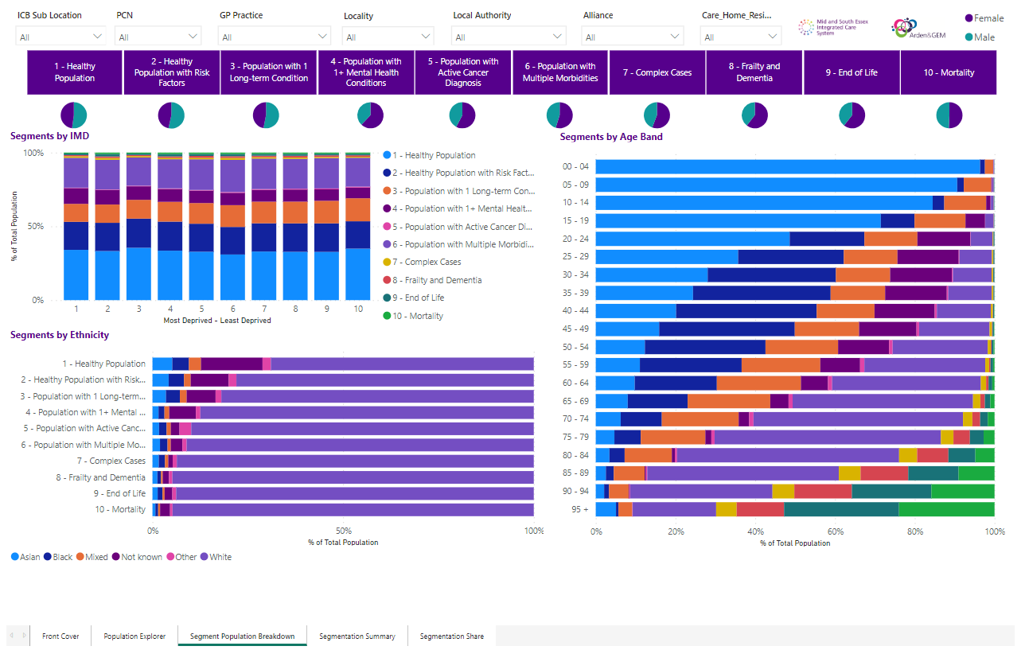

Photo of an example of a data dashboard

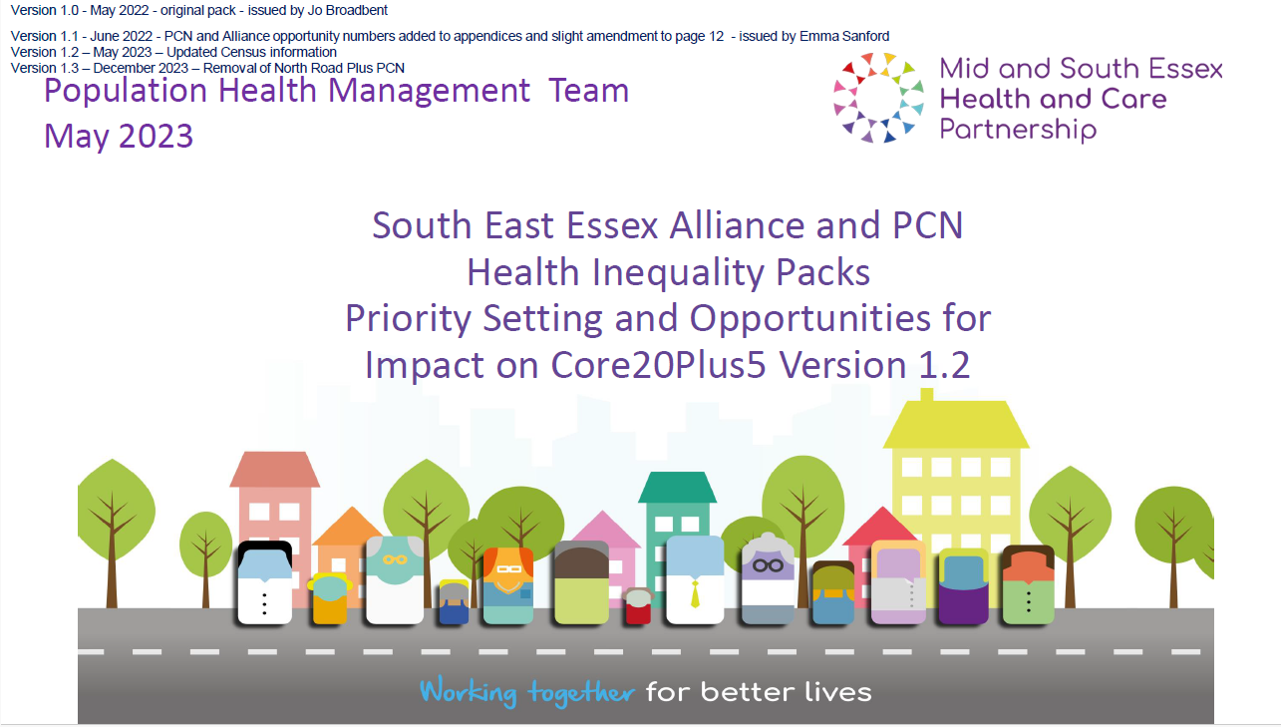

Photo of a Data pack example, titled South East Essex Alliance and PCN Health Inequalities Packs Priority setting and opportunities for impact on Core20Plus5 Version 1.2

## MSE population

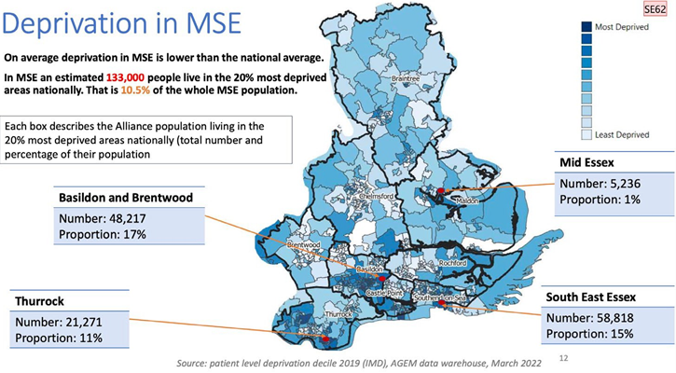

The image is a colour-coded map of mid and south Essex. Labels on the map indicate the names of the 4 Alliance area along with their population living in the 20% most deprived areas and the percentage of their population: Basildon & Brentwood being 48,217 which is a 17% proportion, Mid Essex being 5,236 which is a 1% proportion, Thurrock being 21,271 which is a 11% proportion and South East Essex being 58,818 which is a 15% proportion.

Different shades of blue fill the districts, indicating varying levels of deprivation. High levels of deprivation are shown in Thurrock, Basildon, Canvey, Southend and some part of Chelmsford and Braintree.

## Population structures in Basildon and Brentwood

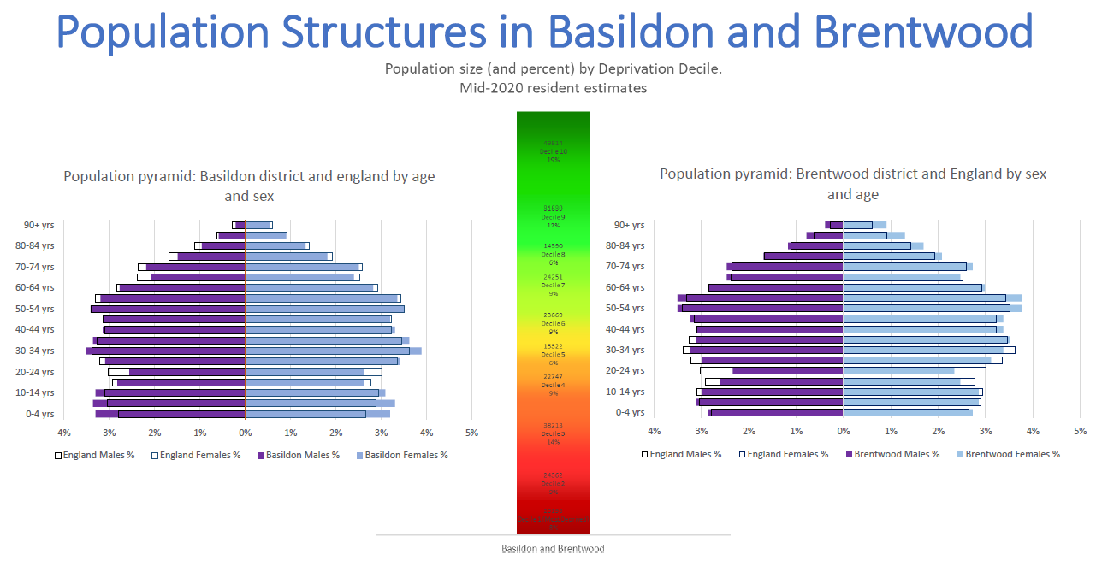

The image shows the population size and percent by deprivation decile, showing the population pyramid for Basildon district comparative to England by age and sex and Brentwood respectively.

17% of the population of Basildon and Brentwood reside in the two most deprived deciles.

In Basildon there is a higher proportion of children 14 years and under compared to the England average

In Brentwood there is a greater proportion of older people aged 55 years and above

## Population structures in Mid Essex

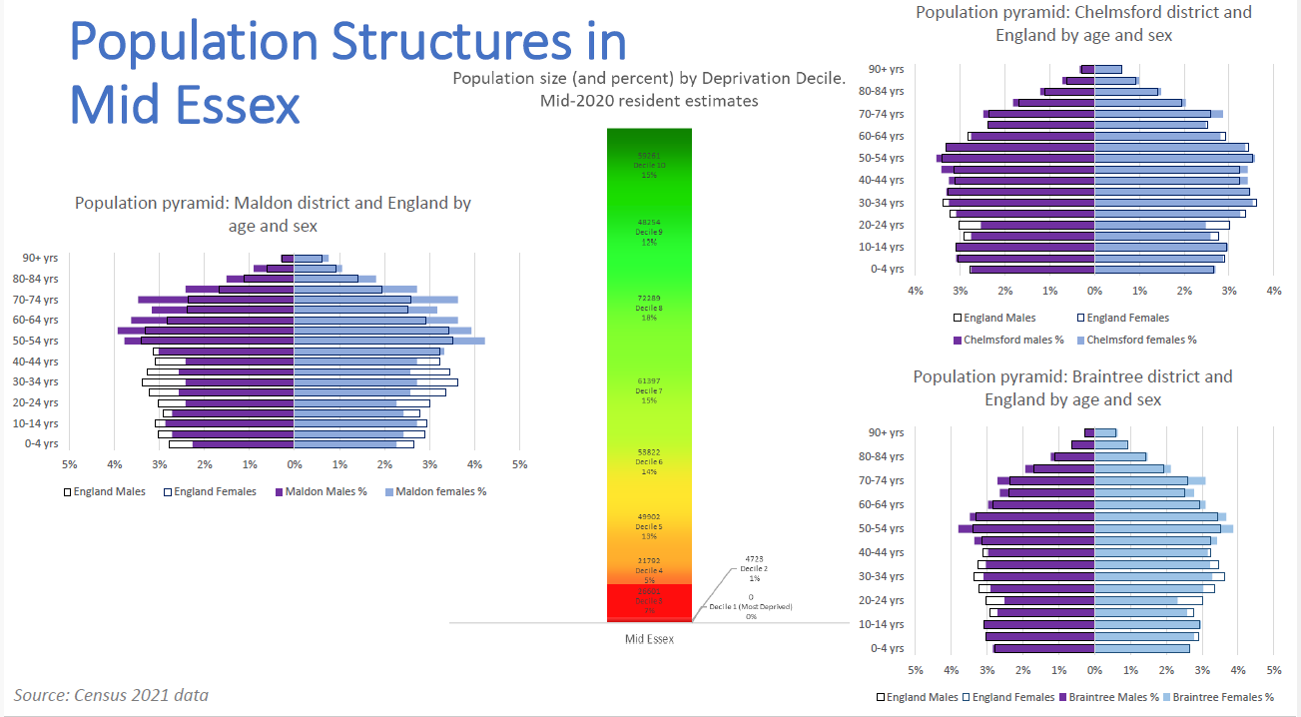

The image shows the population size and percent by deprivation decile, showing the population pyramid for Maldon district comparative to England by age and sex and Braintree and Chelmsford, respectively.

1% of the population of Mid Essex reside in the two most deprived deciles.

Maldon has a significantly older population compared to national average.

In Chelmsford there is a higher proportion of working age 35 years to 65 years.

Braintree also has a higher older population, aged 50 years to 80 years.

## Population structures in South East Essex

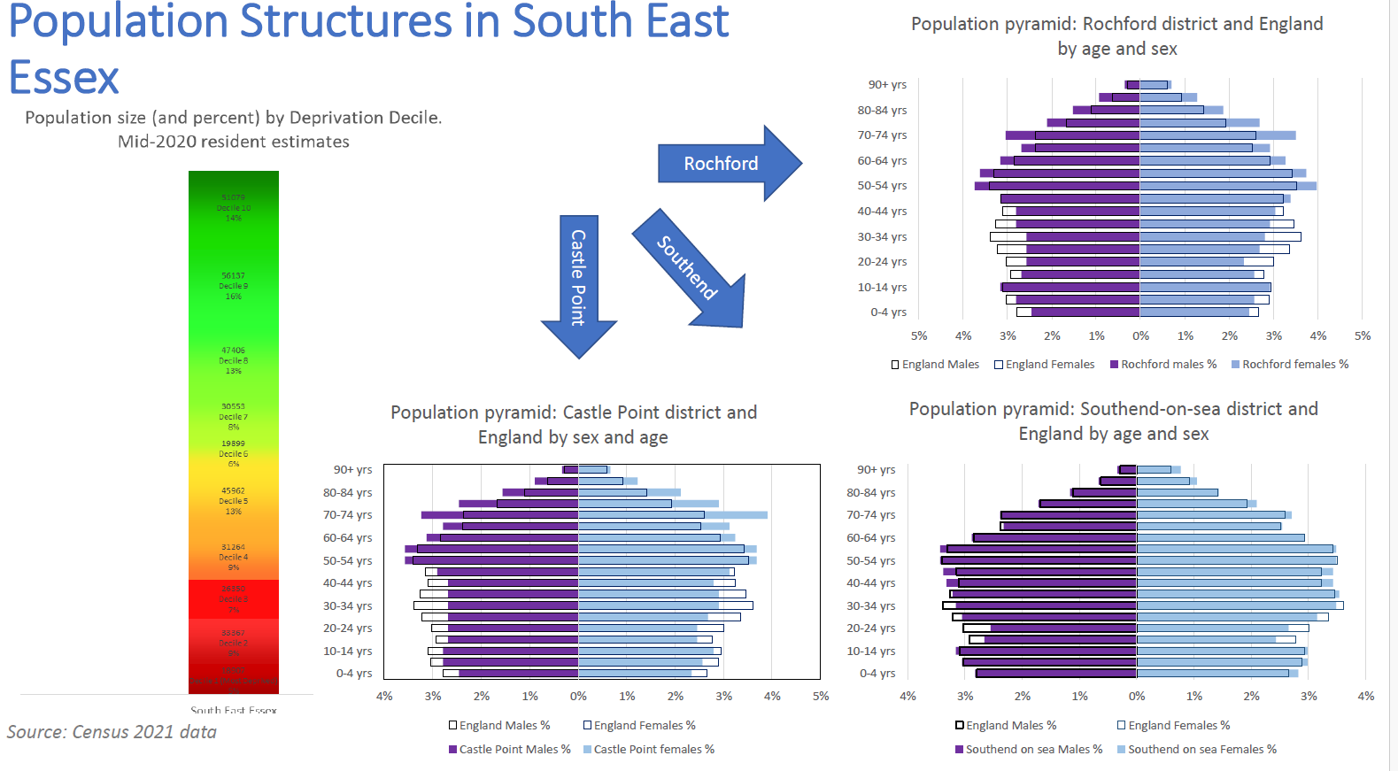

The image shows the population size and percent by deprivation decile, showing the population pyramid for Castle Point district comparative to England by age and sex and Rochford and Southend-on-Sea, respectively.

14% of the population of South East reside in the two most deprived deciles

Castle Point and Rochford have significantly older populations compared to national average. Southend-on-Sea has a higher working age population, aged 40 to 60 years.

## Population structures in Thurrock

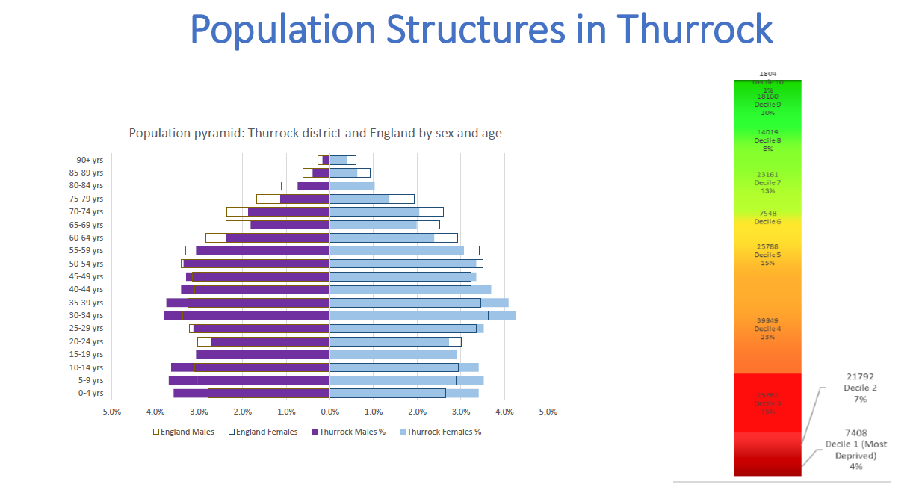

The image shows the population size and percent by deprivation decile, showing the population pyramid for Thurrock district comparative to England by age and sex.

11% of the population of Thurrock reside in the two most deprived deciles.

Thurrock has a higher working age population, aged 30 to 50 years.

## 2021 Census ethnicity data

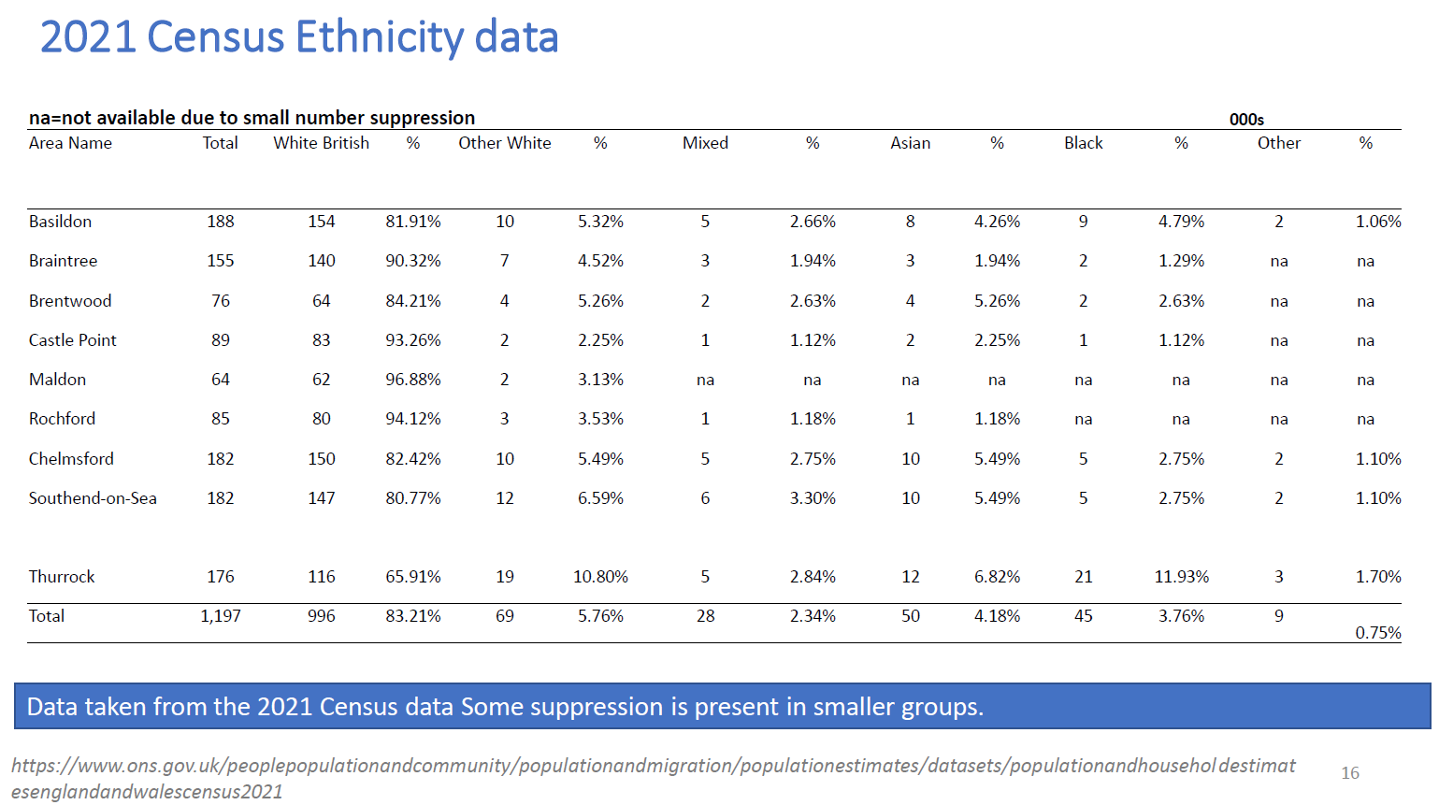

The image shows the 2021 census ethnicity data across the 9 district areas within MSE.

83% of the population of MSE is White British. This is a higher proportion compared to England as a whole 73.5%.

The second largest ethnic group is ‘Other white,’ which represents 5.76% of the MSE population.

Basildon, Southend, and Thurrock have the greatest Black, Asian and Minority Ethnic groups.

## (Healthy) Life Expectancy in MSE

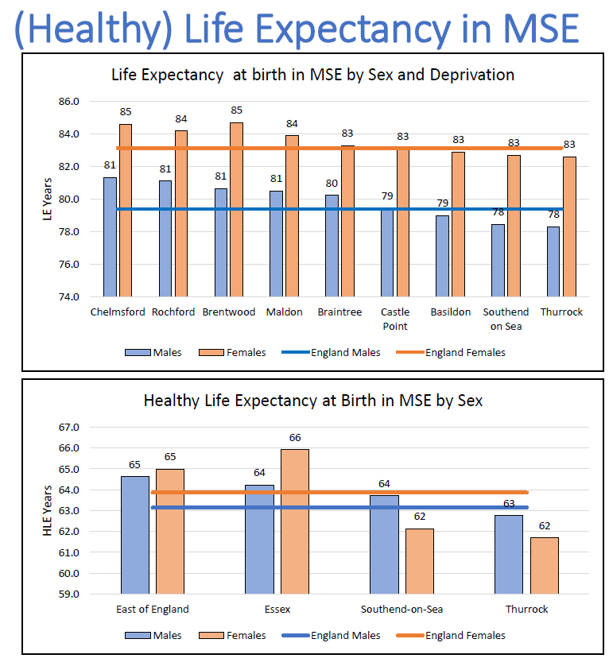

The image shows a graph of life expectancy at birth in MSE by sex and deprivation, showing the 9 areas within MSE, comparing to the England average. Life expectancy for males in MSE varies from 78 years to 81 years, compared to the England average of 79 years. Life expectancy for females in MSE varies from 83 years to 85 years, compared to the England average of 83 years.



The image shows a graph showing healthy life expectancy at birth in MSE by sex, comparing the 3 local authority areas: Essex, Southend-on-Sea, and Thurrock, to the England average.

* Life expectancy is a key metric for assessing a population’s health. Healthy life expectancy indicates how long a population is expected to experience good health.
* Overall, Females have a higher life expectancy than Males.
* Male healthy life expectancy is lower than East of England average across Mid and South Essex but lower than England average only in Thurrock.
* Female healthy life expectancy is higher in Essex than that the England average, however in Southend-on-Sea and Thurrock it is much lower.

## Inequality in Life Expectancy in MSE

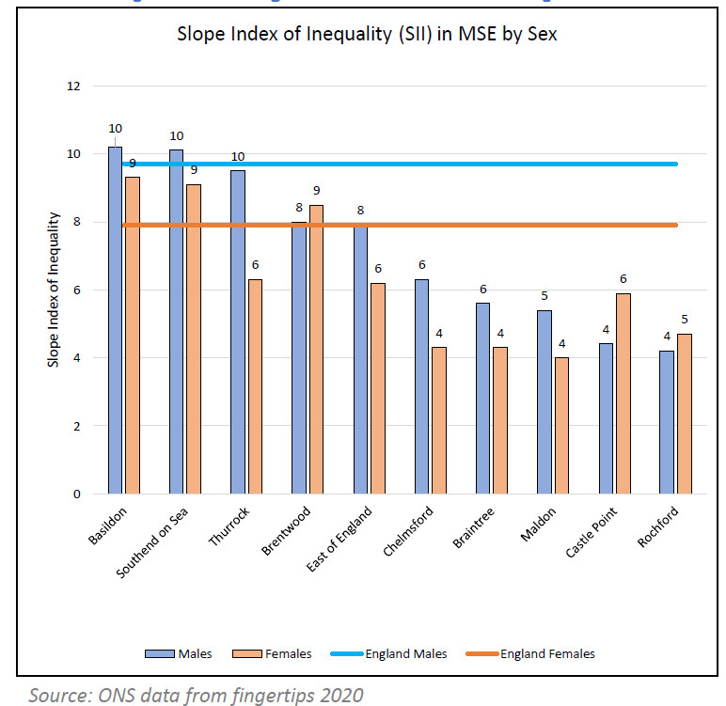

The image is of a graph that shows the slope index of inequality in MSE by sex, comparing the 9 areas within MSE, to the England average.

* The Slope index of inequality is a measure of the social gradient in life expectancy, i.e., how much life expectancy varies with deprivation. It takes account of health inequalities across the whole range of deprivation within each area and summarises this in a single number. This represents the range of years of life expectancy across the social gradient from most to least deprived.
* Basildon and Southend-on-Sea have an inequality gap within their than is greater than the average for England for both men and women. Brentwood has a greater inequality gap than average for women.
* Chelmsford, Braintree, Maldon, Castle Point and Rochford have an inequality gap within their populations that is lower than England average.
* The areas that have a lower life expectancy overall (Thurrock, Southend-on-Sea, and Basildon) also have a greater inequality of life expectancy within their populations.

## Mortality attributable to socioeconomic inequality

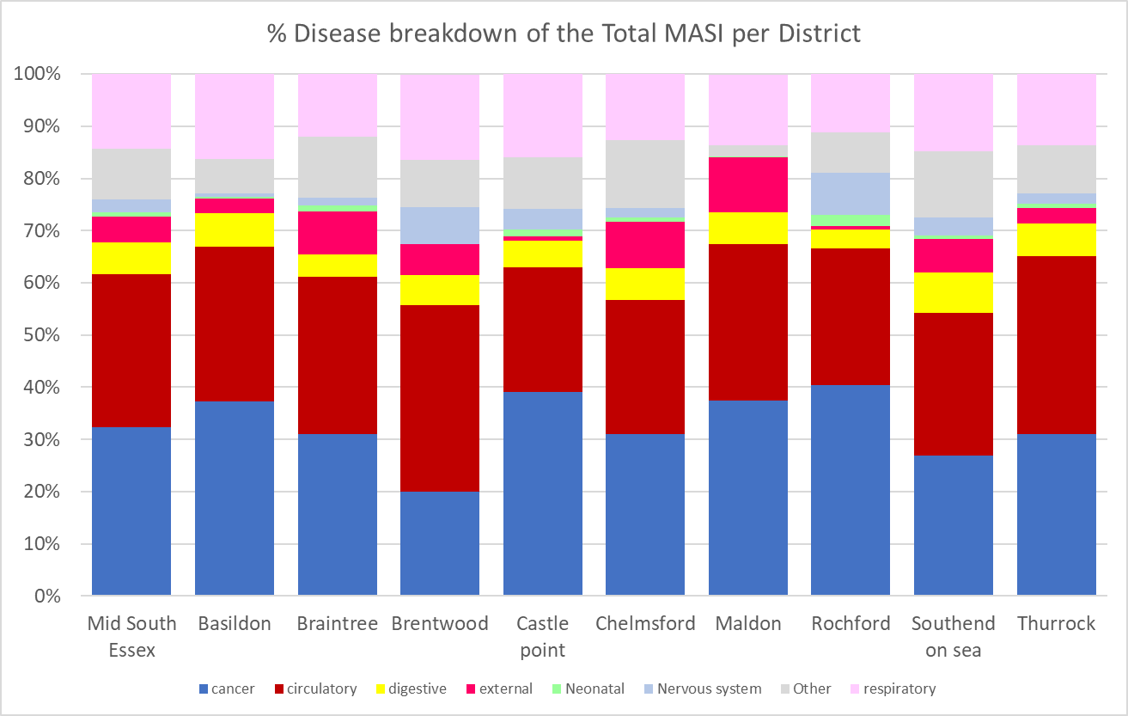

The image is of a graph showing percentage disease breakdown of the total mortality attributable to socioeconomic inequality per district.

* Mortality attributable to socioeconomic inequality (MASI) relates to excess number of deaths compared to the least deprived areas in England.
* There are over 14,500 excess deaths in mid and south Essex relating to socioeconomic inequality.
* The graphs show percentage that each disease category contributing to MSAI overall.
* All districts in mid and south Essex have Cancer, Circulatory disease, and respiratory disease in their top three contributors to MASI.
* Patterns are similar in most districts.

## Health inequalities governance in MSE

governance flow chart

The image shows a flow chart to demonstrate the health inequalities governance in MSE.

MSE established a Population Health Improvement Board with representation from partners across the system to drive an integrated approach inequalities improvement.

This Board brings together programme of work across:

* Health inequalities
* Population Health Management
* Prevention
* Personalised Care
* Anchor programme

The Population Health Improvement Board reports up to both the MSE Integrated Care Partnership to bring together the work around wider determinants of health and to the Integrated Care Board to drive improvements around specific healthcare priorities.

## Mortality MSE has adopted the NHS Core20PLUS frameworks

Reducing Healthcare inequalities: Core20Plus5 adults

Core20PLUS5 adults infographic 



The infographic covers the Core20PLUS5 approach for adults to tackling health inequalities:

**Core20**: The most deprived 20% of the national population as identified by the national Index of Multiple Deprivation (IMD). The IMD has seven domains with indicators accounting for a wide range of social determinants of health.

**PLUS**: PLUS population groups should be identified at a local level. Populations we would expect to see identified are ethnic minority communities; people with a learning disability and autistic people; people with multiple long-term health conditions; other groups that share protected characteristics as defined by the Equality Act 2010; groups experiencing social exclusion, known as inclusion health groups coastal communities (where there may be small areas of high deprivation hidden amongst relative affluence).

Inclusion health groups include people experiencing homelessness, drug and alcohol dependence, vulnerable migrants, Gypsy, Roma and Traveller communities, sex workers, people in contact with the justice system, victims of modern slavery and other socially excluded groups.

**5**: There are five clinical areas of focus which require accelerated improvement. Governance for these five focus areas sits with national programmes; national and regional teams coordinate activity across local systems to achieve national aims.

1. Maternity: Ensuring continuity of care for women from Black, Asian and minority ethnic communities and from the most deprived groups. This model of care requires appropriate staffing levels to be implemented safely.

2. Severe mental illness (SMI): Ensure annual physical health checks for people with SMI to at least nationally set targets.

3. Chronic respiratory disease: A clear focus on Chronic Obstructive Pulmonary Disease (COPD) driving up uptake of COVID, flu and pneumonia vaccines to reduce infective exacerbations and emergency hospital admissions due to those exacerbations.

4. Early cancer diagnosis: 75% of cases diagnosed at stage 1 or 2 by 2028.

5. Hypertension case-finding and optimal management and lipid optimal management: To allow for interventions to optimise blood pressure and minimise the risk of myocardial infarction and stroke.

**Adult Plus groups identified in MSE** that may experience poorer health outcomes:

* Black and Minority Ethnic groups
* Carers
* People with Learning Disabilities
* People experiencing Homelessness
* Gypsy, Roma, and Traveller communities.
* Veterans

Reducing Healthcare inequalities: Core20Plus5 children

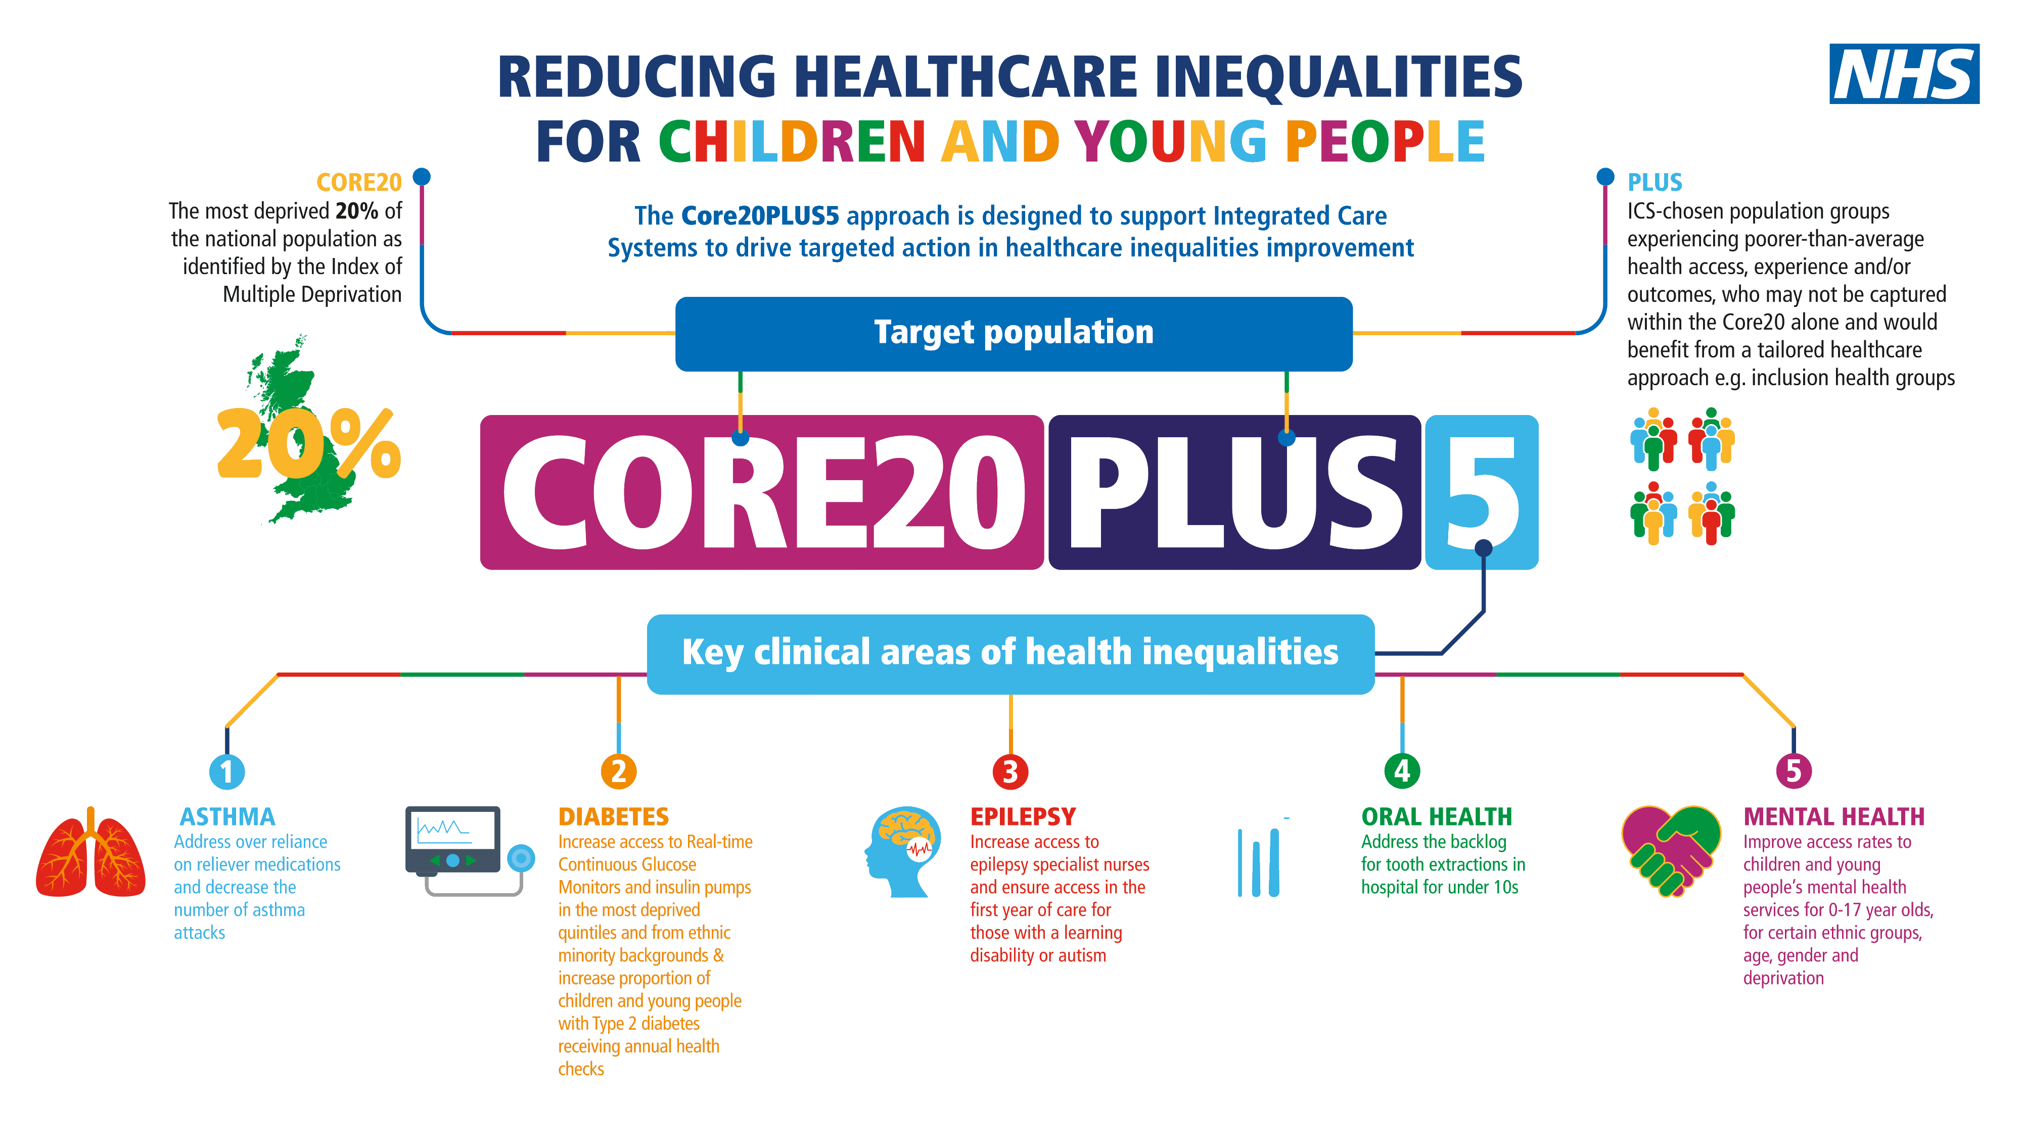

The infographic covers the Core20PLUS5 approach for children to tackling health inequalities:

**Core20**: The most deprived 20% of the national population as identified by the national Index of multiple deprivation (IMD). The IMD has seven domains with indicators accounting for a wide range of social determinants of health. For children and young people wider sources of data may also be helpful including the national child mortality data base and data available on the Fingertips platform.

**PLUS**: PLUS population groups include ethnic minority communities; inclusion health groups; people with a learning disability and autistic people; coastal communities with pockets of deprivation hidden amongst relative affluence; people with multi-morbidities; and protected characteristic groups; amongst others. Specific consideration should be taken for the inclusion of young carers, looked after children/care leavers and those in contact with the justice system.

Inclusion health groups include people experiencing homelessness, drug and alcohol dependence, vulnerable migrants, Gypsy, Roma and Traveller communities, sex workers, people in contact with the justice system, victims of modern slavery and other socially excluded groups.

**5**: The final part sets out five clinical areas of focus. The five areas of focus are part of wider actions for Integrated Care Board and Integrated Care Partnerships to achieve system change and improve care for children and young people. Governance for these five focus areas sits with national programmes; national and regional teams coordinate local systems to achieve aims.

1. Asthma - Address over reliance on reliever medications; and decrease the number of asthma attacks.

2. Diabetes: Increase access to real-time continuous glucose monitors and insulin pumps across the most deprived quintiles and from ethnic minority backgrounds; and

Increase proportion of those with Type 2 diabetes receiving recommended NICE care processes.

3. Epilepsy: Increase access to epilepsy specialist nurses and ensure access in the first year of care for those with a learning disability or autism.

4. Oral health: Tooth extractions due to decay for children admitted as inpatients in hospital, aged 10 years and under.

5. Mental health: Improve access rates to children and young people’s mental health services for 0-17 year olds, for certain ethnic groups, age, gender, and deprivation.

**Children and Young People Plus groups identified in MSE** that may experience poorer health outcomes:

* Young Carers,
* Ethnic minorities
* Roma, Gypsy, Travellers,
* Looked After Children, Care Givers
* Learning Disability
* Special Educational Needs and Disabilities (SEND),
* Neurodiversity (ASD and ADHD, Tics and Tourette’s)
* Young people in the criminal justice system
* Families in Temporary Accommodation,
* Emotionally Based School Avoidance (EBSA),
* Unaccompanied asylum seekers, migrants
* CYP affected by Domestic Abuse

## Addressing health inequalities in everything we do

In 2023/24 the MSE health inequalities programme has focused on developing a culture of addressing health inequalities across all our business areas. In support of that ambition, we have:

* Ensured equitable access through use of Equality and Health Inequalities Impact Assessments to identify impacts of service changes and set out appropriate mitigations to ensure health inequalities are addressed.
* Invested in the development of a digital Equality and Health Inequalities Impact Assessment tool ‘ImpactEQ.’ This will enable us to ensure high quality assessment are delivered consistently and roll out in 2024/25 will be supported by an organisational development approach that emphasises co-designing of services with residents and engaging those from vulnerable groups.
* Developed Health inequalities champions across the system including Finance Fellows as part of the Healthcare Financial Management Association (HFMA) Health Inequalities Finance Programme to support existing health inequalities ambassadors.
* Promoted Narrowing the gap in health inequalities through; the first jointly hosted conference with the Royal College of GPs, a system wide webinar with Allied Health Professionals (AHP) via and promotion of published Core20PLUS5 articles and case studies.
* Showcased the good practice being undertaken in MSE on CVD at national and regional networks. Alongside sharing work on SMI health checks with NHS confederation, NHSE and Institute for Health Improvement as part of being a Core20PLUS accelerator site.
* Embedded evaluation into the work the ICB is undertaking on Health inequalities by working with our partner the University of Essex.

## Working with our most deprived communities – CORE20

Narrowing the gap in health inequalities in our most deprived communities is a priority for all our four Alliance partnerships. Each Alliance has tailored their approach and focused on specific areas, groups or conditions based on the needs of their local populations and the engagement work undertaken with their communities.

**Basildon Alliance**

* Working in partnership with Sport for Confidence to support people with Learning disabilities to access services and make informed decisions about cancer screenings and vaccinations.
* SMI health checks increased to over 60% through collaborative working between Vita Health and GP practices by offering greater choice in preferred location of health checks.
* Established Wellbeing Cafes in collaboration with Motivated Minds and Achieve Thrive Flourish to provide support on a range of topics including mental health, health and wellbeing, nursing, childcare, housing officers, social services, and Citizens Advice Bureau. The cafes offer a mixed programme of activities including social, exercise, talks on health-related topics. The cafes have shown to support participants to:
  + Develop social interactions and relationships, reducing feelings of isolation.
  + Improve physical activity.
  + Access to other voluntary and statutory services
  + Build resilience, provide coping mechanisms, and reduce dependency on the health services.

**Mid Alliance**

* Utilising the Thriving Places index (TPI) to provide a framework to identify those groups that are most of risk of health inequalities but also includes community indicators such as housing quality, education, and green infrastructure.
* In 2023/24 there has been a focus on the following population interventions; Serve Mental Illness (SMI) and Learning Disability health checks, Colne Valley Low Carb Programme, weight management services, sensory wellbeing specialist service and roll out of MSE wide initiatives.
* Clinical outreach scheme led by Chelmer PCN in partnership with, amongst others, Sanctus, Chess and Provide to support to those experiencing homelessness to develop confidence to engage with statutory services.

**South East Alliance**

The priorities in 2023/24 were:

Mental health & wellbeing, incorporating supporting long-term independence; Aging Well; unpaid carers and autism.

* Weight management, physical activity & obesity.
* Alcohol & substance misuse.
* Supporting long term independence incorporating social prescribing and loneliness and self-care community resilience.
* Health inequity and wider determinants of health incorporating: the food environment and food poverty, homelessness, and accommodation (decent, affordable, stable).

**Thurrock Alliance**

The focus in 2023/24 was:

* Obesity and Weight management. Nearing 10,000 adults identified and contacted to attend healthy lifestyle clinics.
* Tobacco control. A tobacco control strategy and smoking cessation implementation plan has been in place, the current activity is focussing on small businesses in Thurrock, providing training, stop smoking packs, and ongoing support to the 16 companies that have signed up to this initiative.
* Hypertension detection and management. A proactive initiative designed to reduce the number of cardiac events by the additional involvement of pharmacies, to support individuals at medium risk of CVD-related events with a diagnosis of hypertension that this not being actively treated.

## PLUS groups

The ICB PHM team are developing local data and insight for the ‘PLUS’ groups within MSE to identify areas of greatest need and best practice interventions. However, based on national insight we continue to undertake programmes of work to address underlying health inequalities in our ‘PLUS’ groups including:

**Ethnic Minority Groups**

* Changing the way GP practices communicate with patients in BAME community by encouraging face to face meetings to help break down cultural barriers and allay concerns to improve uptake in cancer screening

**Veterans**

* Using Veterans voices to inform how services are delivered utilising research conducted by Healthwatch. MSEFT awarded veteran aware accreditation.

**Homeless**

* Bringing together the NHS, Southend-on-Sea City Council, food banks, soup kitchens, hostels, outreach teams, hospital, mental health, and substance misuse providers to deliver an integrated health service to those experiencing homelessness.

**People with Learning disabilities**

* Implementation of improvement plan has seen a year-on-year increase in % of individuals having a health check through greater partnership working between the LD specialist health team and primary care colleagues

**Gypsy, Roma, Traveller Communities**

* Improving access to health services in Thurrock through a monthly programme of visits to deliver preventive health interventions and facilitate registration with a GP practice.

**Inclusion health groups**

* MSE first ICS in EoE to commission Pride in Practice offering free training and support to over 25 accredited practices.

## 5 Clinical Priorities - Adults

Work has continued in 2023/24 around the five clinical priority areas for adults:

**Maternity**

* Implementation of the Maternity Equity and Equality action plan reduce risk of preterm births with focus on those from a black ethnic background.
* Creation of a patient information leaflet highlighting the risks around ethnicity
* Introduction of preterm birth digital tool ‘QUiPP’ app to improve prediction and care of those who may be in preterm labour.
* Launch of Smoke Free Pathway including provision of in-house smoking cessation support

**Severe Mental Illness**

* Spread of learnings across localities with strengthening of relationships between primary care and VCSE partners.
* Participation in NHSE Core 20 accelerator site with focus on quality improvement and co-production
* Delivered year on year improvement in uptake of annual health check and performance in upper quartile nationally.

**Respiratory**

* Continued focus on promoting Covid and Flu vaccine uptake with at risk groups.
* Adopting a Make Every Contact Count (MECC) approach as part of outreach work.
* Delivering higher uptake across most ethnicity groups in MSE compared to national average.
* Launch of Pneumococcal vaccine awareness and education campaign, with easy-to read document developed in partnership with voluntary sector groups to increase awareness and uptake among those with learning disabilities.

**Cancer**

* PCNs act on data received on cancer screening uptake by deprivation and at-risk groups.
* Development of culturally competent communication with videos from local doctors about how to recognise signs and symptoms of some of most common cancers.
* Expansion of national lung cancer screening programme to Castle Point and Rochford with continuation in Thurrock and Southend.

**Hypertension**

* Over 92,000 residents participating in the programme with distribution of 2,000 blood pressure machines to GPs in most deprived areas.
* Outreach clinics undertaken in deprived areas of Southend to improve identification and management of hypertension.
* On trajectory to achieve national targets regarding hypertension management and prescribing of cholesterol lowering therapies

## 5 Clinical Priorities - Children and Young People

Work has continued in 2023/24 around the five clinical priority areas for children and young people:

**Asthma**

* Utilising data to identifying those most at risk of exacerbations and who would benefit from proactive care.
* Roll out of Childhood Asthma training for primary care.
* Encouraging access to education tool for children and their family to support them in learning more about asthma, triggers, and effective management.

**Diabetes**

* Improvement plan in development in Q4 of 2023/25 to increase access to Continuous Glucose Monitoring and insulin pumps within agreed protocols and NICE Guidance by 2025/26

**Epilepsy**

* Improvement Plan is under development overseen by the MSE Growing Well Board to implement the national care bundle for children and young people with Epilepsy.

**Oral Health**

* Adoption of a system wide approach to child oral health working across health providers, education sector, public health and with community and voluntary sector groups
* Thurrock was chosen by NHSE as pilot site for Early Year Oral Health Improvement through its Family Hubs
* Initiatives include supervised toothbrushing in earl years and distribution of toothbrush packs.

**Mental Health**

* Growing Well Board has prioritised SEND and neurodiversity and committed health inequalities funding toward pre and post diagnosis support.
* Recruitment of PCN based Children and Young People’s Mental Health Practitioners commenced.
* Working in partnership across system to strengthen early intervention, support and education for Schools and Colleges.

## Planning priorities 2023/24 – Health inequalities

**Restore NHS services inclusively**

* Elective Recovery Equality Health Impact Assessment completed with mitigation action to reduce identified barriers to access.
* Elective waiting list data analysed by ethnics, sex, and deprivation with regular reporting to MSEFT Board and Elective Care Board
* Gap in waiting times between the most deprived and second most deprived areas halving in last 23 months.

**Mitigate against digital exclusion**

* Access to primary, secondary and community care continues to be offered via digital, face to face and by telephone for all.
* Digital Inclusion Framework established with principles being adopted by all partners within the ICS.
* Recruitment to digital transformation roles with primary care and existing social prescribing link workers and health and wellbeing coaches to support patient with access via digital health apps and improving digital and health literacy.
* Working closely with local authorities to support digital infrastructure, digital affordability, and signposting patients.

**Ensure datasets are complete and timely**

* Shared Decision Making four questions campaigned rolled out to support personalisation in primary care.
* Targeted investment in Health Inequalities, contracting Alliance ‘trusted partners’ to facilitate investment in local schemes.
* Hosted ‘Narrowing the Gap’ conference with RCGP for over 80 system attendees, including primary care and VCFSE.

**Accelerative preventative programmes**

* MSE ICB continues to accelerate prevention programmes through its adoption of the Core20PLUS5 frameworks.
* CVD Prevention programme supported with Health inequalities funding has delivered improvements in hypertension and lipid management.
* Launch of tobacco cessation programme for inpatient services and pregnant women
* Increased access to weight management services

**Strengthen leadership and accountability**

* Clear leadership, governance, and accountability for health inequalities through the Population Health Improvement Board reporting to ICB Board and the Integrated Care Partnership
* Clinical leadership strengthened with two system clinical leads in post, Alliance Clinical Leadership and PCN Health Inequalities focused on delivering reductions in health inequalities across all levels with the system.

## Health inequalities Funding

The ICB committed £3.4m of its baseline funding towards reducing health inequalities. Its approach evolved in 2023/24 with appointment of ‘Trust partners’ in each Alliance, predominately CVS organisations to support the administration and management of the funds.

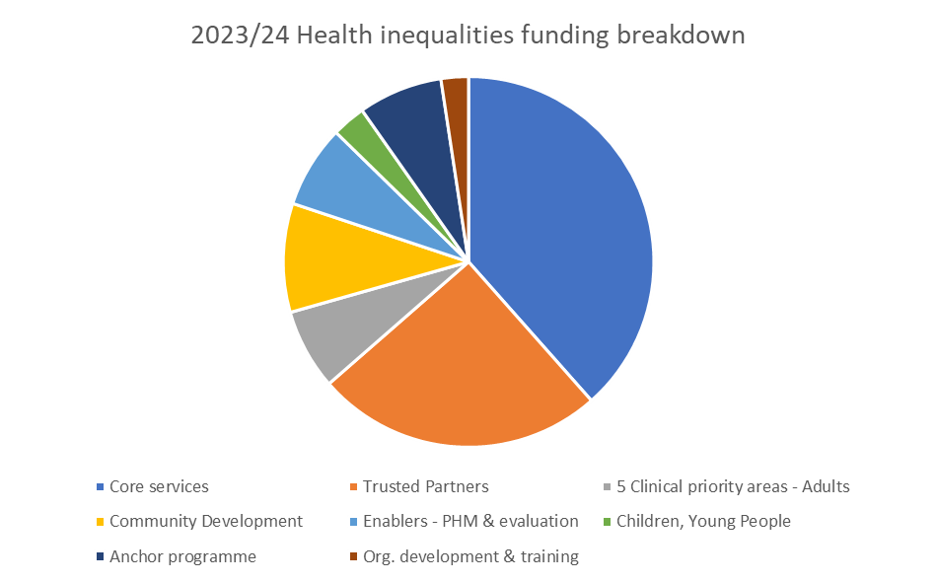

The image is of a pie chart showing 2023/24 health inequalities funding breakdown showing the two biggest proportions of spend going to Core services and trusted partners. Other spends in order of proportion are community development, anchor programme, Enablers – PHM & evaluation, 5 clinical priority areas – adults, children, and young people and lastly organisation development and training.

The funding supported reducing health inequalities across its Core services, Core20PLUS5 priorities and to meet identified local population needs.

Funding has been committed against a smaller number of schemes in 2023/24 with a focus on clinical priority areas of cardiovascular disease and cancer.

The Growing Well Board has prioritised funding to reduce health inequalities via an Oral Health Programme and Pre and Post Neurodiversity Diagnosis Support for children and young people.

In 2022/23 the ICB committed its £3.4m health inequalities funding from NHSE to support over 70 innovative projects to reduce health inequalities against the Core20plus5 priorities and to meet local population needs. The ICB is working with the University of Essex to evaluate the impact of these schemes.

**Basildon – Feeding the family; Give, Guide, Grow**

Provided support for 700 low-income families including teaching cooking, hygiene advice and tips on reducing food waste, energy, and bills. Recipients reported positive impact on their lives with reduced social isolation and loneliness.

**Southend – Let’s Keep Moving and Age Better**

Over 100 people with multiple long-term conditions supported by Community Interest Company to increase levels of physical activity, improve healthy weight and reduce risk of falls.

**Mid Essex – Young Carers Thrive**

Provided support to 200 young carers and family members in Mid Essex. Participants reported improvements in managing their carer responsibilities and feeling happier at school as a result of the programme’s support.

**Thurrock – Access to health services**

Monthly programme of health and wellbeing services visits across 5 main gypsy, Roma, Traveller sites. 210 patients seen, with 16 new patients registered with the GP, a fifth reviewed by pharmacist, 13% referred to GP for review of diabetes, hypertension, or cholesterol.

## Health inequalities Indicators 2023/24

## Domain: Elective Recovery

**Elective waiting lists**

* Mid and South Essex Foundation NHS Trust reports regularly to their Board on health inequalities within elective waiting lists as part of the integrated performance report
* Elective Recovery Equality Health Impact Assessment completed with mitigating actions outlined and reported to the Elective Care Board
* Community Collaborative have set out a programme for reviewing health inequalities across priority areas of Virtual Ward (admissions), UCRT (referrals), IMC and Stroke beds (admission), Community Paediatric (all waits) in 2024/25.
* Further work is to be undertaken in 2024/25 to identify and address health inequalities within elective waiting lists and activity.

**Indicator: Elective waiting lists**

Ethnicity Focus. There is an under-representation in all ethnicities except "other ethnic group" on the waiting lists. Under-representation can suggest difficulty in accessing care.

Black, Asian, and Mixed patients are all under-represented, Therefore, it is important to focus on whether patients from an ethnic minority background are having difficulties accessing care. There is a 20-25% gap in recording of ethnicity data which is impacting our ability to understand if patients are under-represented or just unknown in the data.

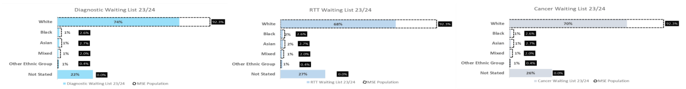

Image showing 3 graphs showing ethnicity in relation to; Diagnostic waiting list 23/24, RTT waiting list 23/24 and cancer waiting list 23/24.

Gender Focus. Females are over-represented, meaning they are more likely to appear on our waiting lists than males. This could be attributed to females living longer than males in MSE. The next step is understanding if females have longer waiting times based on population distribution or delays in receiving treatment.



Image showing 3 graphs showing gender in relation to; Diagnostic waiting list 23/24, RTT waiting list 23/24 and cancer waiting list 23/24.

Age Focus. Our age distribution in hospital does not reflect that of the population. We see an over-representation of patients over 65, but this is expected. Our previous analysis did not suggest over 65s are waiting longer.

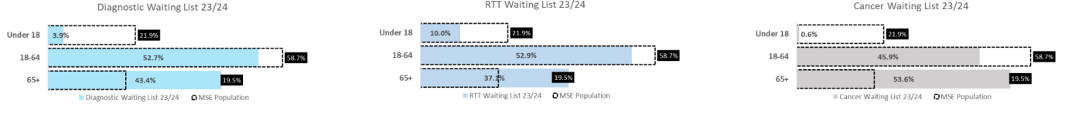

Image showing 3 graphs showing age in relation to; Diagnostic waiting list 23/24, RTT waiting list 23/24 and cancer waiting list 23/24.

Deprivation Focus. Those living in the 2nd most deprived quartile are over-represented on our waiting lists and those in the least deprived areas are under-represented. This could suggest our more deprived populations have poorer health outcomes and/or our more deprived patients are waiting longer.

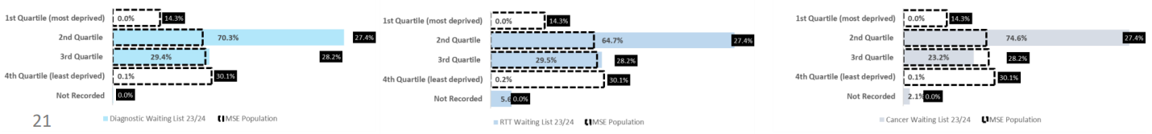

Image showing 3 graphs showing deprivation in relation to; Diagnostic waiting list 23/24, RTT waiting list 23/24 and cancer waiting list 23/24.

**General projects**

**Patient Communication**: Work being taken forward by Associate Director Patient Experience & Engagement. Patient communication strategy meeting held Feb 24.

**National Voices:** Preparing end of project report on Lived Experience Coaching to share learning. Lived experience is a key theme in MSEFT 10-year strategy development programme using recommendations from the National voices report. Two insight reports – 1. Experiences of people with Dementia and 2. experiences of shared decision-making being used for project development.

**Digital EHIA Assessment Tool and Improved Staff Training and awareness:** ICS wide tool will significantly improve how staff approach and complete meaningful assessments for service changes impacting people with protected characteristics. Final elements are now being completed and testing /soft launch is underway. Contract and commercial issues are being resolved with the help of a specialist. Last business case to finalise future maintenance funding will be shared with leads once commercial considerations have been confirmed.

**Anchor Social Value:** Final Social Value session to develop Framework for Mid and South Essex completed 11 Jan 24. Next steps for detailed plans and community/ business consultation to be worked up and completed by early summer 2024. Team also supporting conversation on updated Anchor Charter for all ICS partners and successfully delivered an event on 27th Feb, which was attended by more than 75 partners supporting Anchor.

**MSE Innovation fellowships:** Cohort 4 launched 6 November 23 - focus on inclusion health, education & training, and net zero. 18 new fellows, 27% MSEFT, 26% ICS and remainder from clinical entrepreneur programme or small/medium enterprises. 59 Alumni Fellows, 12 with strong link to health inequalities. Preparations underway for Cohort 5 Fellowship themes.

**Projects under theme of Access**

**Integrated Impact Assessment for Community Beds:** Strategy Unit have produced an Integrated Impact Assessment for Community Capacity. This is currently in the public domain as part of the public consultation.

**Working Age Women:** Focus Groups have been held with Patients and Staff to understand the restrictions, opportunities and issues faced. Some feedback has been analysed and Strategy leads are considering the regional women's hubs for this work.

**Rapid Diagnostic Centre and Endoscopy short films and Easy Read Leaflets:** Short films and leaflets supporting patients with LD and/or anxiety etc. when they access services are being finalised. LD team presenting a poster on their work with LD ambassadors at the IHI forum in London on 11-12 Apr.

**OVRcome:** Project won 'Diversity In Innovation' award at the Innovation Awards 2023. Successful SBRI bid awarded Nov 2023 for £438K, with the project starting 2 Jan 2024. 6 co-production sessions held (5 initial & 1 final session) for those with lived experience, supporters, and staff. Feedback and plan for video/content creation socialised at final session; 104 contributions across the sessions and survey. 20 participants recruited for pilot. Medical device regulatory work underway for the OVRcome tool. Presented to EOE Regional Community Learning disability and Acute Liaison Nurse Forum.

**Veterans' Aware accreditation**: MSEFT secured Veteran's Aware Accreditation by March 2024, with the identification of the following best practice; governance (working group), Patient identification, staff training, communications, and recruitment.

**Projects under theme of Outcomes**

**CardMedic**: 858 users (increase of 35) are registered, and maternity has been particularly engaged with this project. CardMedic covers all specialty areas, with 49 languages now available. CardMedic working group provide guidance for future projects and remote engagement across MSEFT. MSEFT feedback survey completed on usage of CardMedic. Ongoing work around inclusion within Translation policy. Exploring funding routes for contract renewal.

**Industrial Action Analysis:** Strategy Unit produce industrial action impacts analysis regularly to Execs and board to ensure understanding continues to grow. Last analysis shared March 24 public board.

**Youth Work in Hospital:** Expansion of original programme close to mobilisation. Extension into Long Term Conditions is advanced with youth work practitioners joining Long Term Conditions Clinic for Diabetes and Epilepsy. Additional funding to extend project to October 2025 - will greatly assist establishing new service and extending to all three hospitals. Includes development of Southend test cohort which is currently in planning stage.

**Anchor Ambition 25:** Project has completed mobilising Mid and South Essex expansion plan including on-boarding of four Anchor Ambition Employment Support Officers. Community hubs identified - with revised capacity the project has seen numbers increase exponentially to 1,004 participants and 196 job offers since Feb 23. Project has delivered Hundo component supporting MSE's pipelines and commenced delivery of its traineeships for disadvantaged young people (Care Leavers).

**Projects under theme of Experience**

**Learning Disability Understanding Inequalities Co-Design Programme** LD programme is being delivered by the LD service as BAU. Reasonable adjustment cards available since February following printer set up. Makaton Training is available.

**User Centred Design (UCD)** Better Letters are live in Renal, Pain, Audiology (Southend), Virtual Visits, and ORC service clinics. DNA reduction is evident in some of the more established areas. The team are working with the Outpatient Transformation Programme rolling out pilots with audiology; cardiology; gastro; general surgery and breast; neurology, oncology; paeds; respiratory; upper GI, colposcopy and vascular. Team are also looking at clinical letters for the Cervical Screening Service. Urology and the ORC Fast Track team are also now on board.

**Shared Decision Making**. The programme has secured resources through the Portfolio Board decision in early April to help develop a methodology with pilot services that will then be rolled out across the organisation.

## Domain: Respiratory

**Indicator: Uptake of COVID vaccination by socio demographic group**

Graph 1: the uptake of Covid vaccination by socio demographic group - performance by deprivation quintile

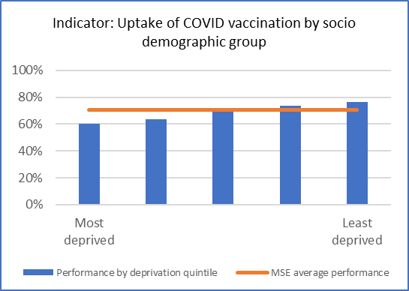Graph 1 shows the uptake of Covid vaccination by deprivation quintile, with quintile 1 (most deprived) being 60%, quintile 2 being 63%, quintile 3 being 71%, quintile 4 being 74% and lastly quintile 5 (least deprived) being 76%, comparative to the MSE average performance of 70.3%.

Graph 2: Uptake of Covid vaccination by socio demographic group - performance by ethnicity

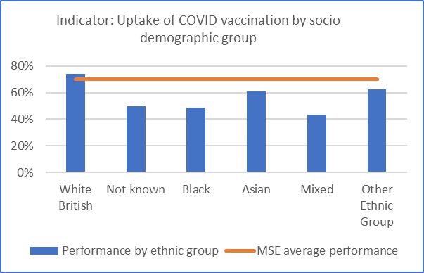Graph 2 shows the uptake of Covid vaccination by ethnic group, with white British being 73.8%, not known being 49.5%, black being 48.9%, Asian being 60.9%, mixed being 43.3% and lastly other ethnic group being 62.4%, comparative to the MSE average performance of 70.3%.

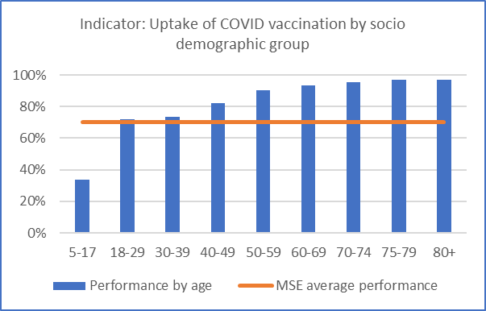Graph 3: Uptake of Covid vaccination by socio demographic group - performance by age

Graph 3 shows the uptake of Covid vaccination by age, with age range 5-17 being 33.6%, 18-29 being 72.1%, 30-39 being 73.3%, 40-49 being 82.1%, 50-59 being 90.3%, 60-69 being 93.6%, 70-74 being 95.3%, 75-79 being 96.8% and lastly 80 and over being 97.1%, comparative to the MSE average performance of 70.3%.

**Observed health inequalities**

* Higher levels of vaccination are observed in less deprived and older age groups. In addition, ethnicity has an impact of relative rates of vaccination with White British having the higher levels of vaccination and mixed, black, and unknown ethnicities having lower levels of vaccination. Further analysis is being undertaken but initial review suggests that this is not down to access as there not a significant variation in uptake in relation to proximity to vaccination services amongst different areas of deprivation.

**Action being taken to address these health inequalities**

* Building on the successes of the initial covid vaccination programme, various targeted initiatives have been undertaken to try and improve uptake rates in specific cohorts of the population. We have increased the number of venues offering covid vaccinations particularly in areas of Southend, Basildon, and Thurrock. A number of pop-up vaccination clinics are run targeting areas with historically low uptake. Our comms campaign targets particular postcodes in areas of high deprivation through a variety of mechanism such as bus adverts, social media adverts and other promotional campaigns. PCNs maintain links into key communities and leads within those communities to try and encourage uptake. We will review the autumn/winter campaign to understand areas of greatest impact and then spread good practice.

*Source: Foundry (NHS England Data Extraction as at 23/01/24)*

**Indicator: Uptake of flu vaccination by socio demographic group**

Graph 1: the uptake of flu vaccination by socio demographic group - performance by deprivation quintile

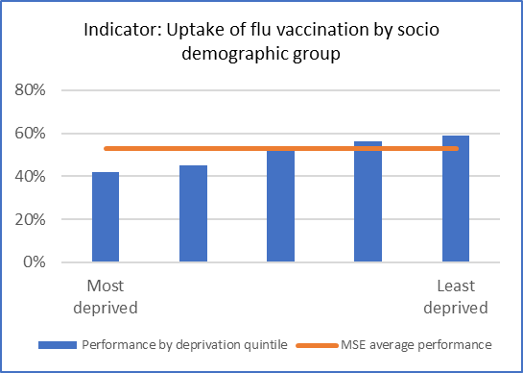Graph 1 shows the uptake of flu vaccination by deprivation quintile, with quintile 1 (most deprived) being 42%, quintile 2 being 45%, quintile 3 being 53%, quintile 4 being 56% and lastly quintile 5 (least deprived) being 59%, comparative to the MSE average performance of 53%.

Graph 2: the uptake of flu vaccination by socio demographic group - performance by ethnicity

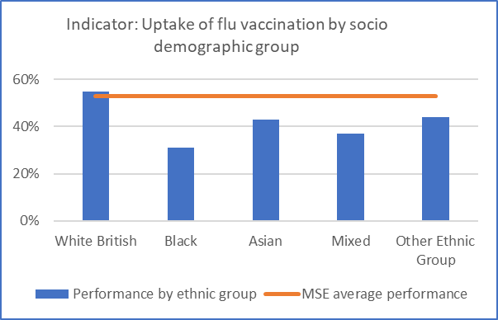Graph 2 shows the uptake of flu vaccination by ethnic group, with white British being 55%, black being 31%, Asian being 43%, mixed being 37% and lastly other ethnic group being 44%, comparative to the MSE average performance of 53%.

Graph 3: the uptake of flu vaccination by socio demographic group - performance by age

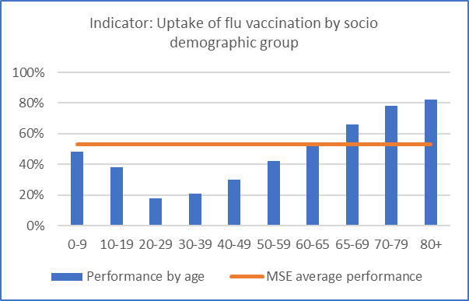Graph 3 shows the uptake of flu vaccination by age, with age range 0-9 being 48%, 10-19 being 38%, 20-29 being 18%, 30-39 being 21%, 40-49 being 30%, 50-59 being 42%, 60-65 being 54%, 65-69 being 66%, 70-79 being 78% and lastly 80 and over being 82%, comparative to the MSE average performance of 53%.

**Observed Health inequalities**

* Across the various vaccination programmes in Mid and South Essex there is a consistent inequality in levels of vaccination across two key factors - deprivation and ethnicity. There is a general trend that the lower the levels of deprivation, the higher the rate of vaccination. Analysis suggests that this is not driven by access to vaccinations with the number of places offering vaccinations not varying significantly between areas of high and low deprivation. Willingness to engage in the vaccination programme appears to be the most significant factor. Efforts to address the variation must be targeted at engaging with more deprived communities on the importance of the vaccination programme.
* For ethnicity, vaccination rates amongst white British cohorts are higher than other ethnicities. Rates are particularly low amongst the black population.

**Action being taken to address these health inequalities**

* Data is being analysed at a Primary Care Network level to understand which PCNs had a greater impact on addressing inequality. The Covid and Flu Vaccination team are working with those PCNs to cascade best practice. We will utilise access and inequalities funding to invest into initiatives that demonstrate an impact. We will continue with the promotion of covid and flu vaccines as part of our overarching winter campaign.
* Building on the success of the Covid vaccination

*Source:*Foundry (NHS England Data Extraction as at 23/01/24)

## Domain: Mental Health

**Indicator: Overall number of severe mental illness (SMI) physical health checks**

Graph 1: Overall number of severe mental illness (SMI) physical health checks – performance by deprivation quintile

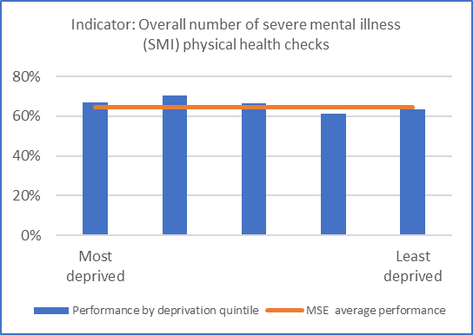Graph 1 shows the overall number of severe mental illness (SMI) physical health checks performance by deprivation quintile, with quintile 1 (most deprived) being 66.8%, quintile 2 being 70.6%, quintile 3 being 66.5%, quintile 4 being 61.3% and lastly quintile 5 (least deprived) being 63.5%, comparative to the MSE average performance of 64.6%.

Graph 2: Overall number of severe mental illness (SMI) physical health checks – performance by ethnicity

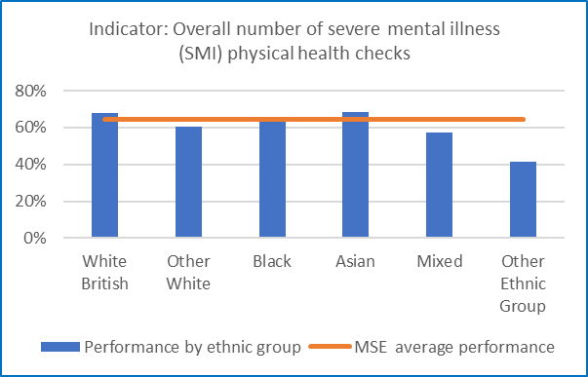Graph 2 shows the overall number of severe mental illness (SMI) physical health checks performance by ethnic group, with white British being 68.1%, other white being 60.3%, black being 64.5%, Asian being 68.6%, mixed being 57.5% and lastly other ethnic group being 41.4%, comparative to the MSE average performance of 64.6%.

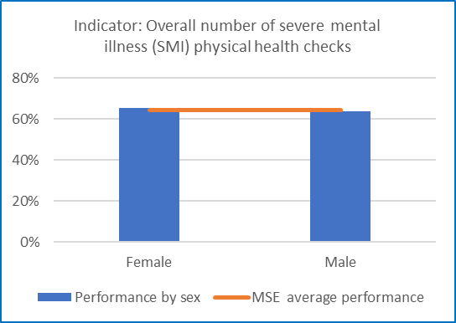Graph 3: Overall number of severe mental illness (SMI) physical health checks – performance by gender

Graph 3 shows the overall number of severe mental illness (SMI) physical health checks performance by gender, with female being 65.4% and male being 63.8%, comparative to the MSE average performance of 64.6%.

Graph 4: Overall number of severe mental illness (SMI) physical health checks – performance by age

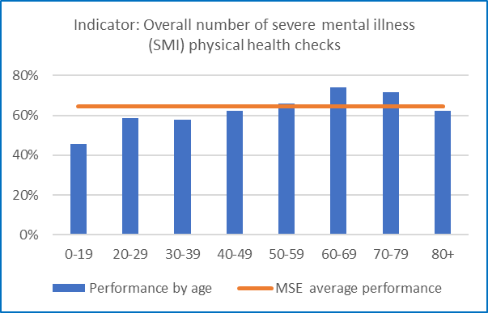Graph 4 shows the overall number of severe mental illness (SMI) physical health checks performance by age, with age range 0-19 being 45.6%, 20-29 being 58.7%, 30-39 being 58%, 40-49 being 62.4%, 50-59 being 65.8%, 60-69 being 73.9%, 70-79 being 71.6% and lastly 80 and over being 62.2%, comparative to the MSE average performance of 64.6%.

**Observed health inequalities**

* Uptake does not significantly vary by deprivation, but analysis shows lower uptake in younger age groups
* Performance by ethnic group highlights that those identified as other white and other ethnic group have lower uptake.

**Action being taken to address these health inequalities**

* Review of patient data of SMI patients currently accessing health checks to identify the demographics of those who are underrepresented, these groups will be targeted for engagement which might be informed by ethnicity, age, gender, or geographical location.
* Participation in the Core20plus accelerator programme to take a quality improvement and engagement approach to improve uptake.
* Engagement with stakeholders completed to gather insight on their experience of, and potential barriers to accessing their annual physical health check.
* Engagement with patients and carers to understanding their experience of, and barriers that exist to accessing subsequent interventions to improve health e.g., smoking cessation and weight loss
* Adapting communication methods by increasing proportion of patients contacted by phone and offering home visits for those who are unable to attend practices.

*Source: MSE local dataset – Athena*

**Indicator: Rates of total Mental Health Act detentions**

Graph 1: Rates of total Mental Health Act detentions – performance by deprivation quintile

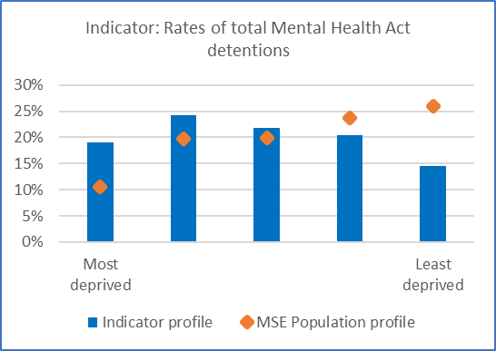Graph 1 shows rates of total Mental Health Act detentions by deprivation quintile, comparing the indicator profile against the MSE population profile, with quintile 1 (most deprived) being 19.1% compared to 10.6%, quintile 2 being 24.2% compared to 19.6%, quintile 3 being 21.7% compared to 20%, quintile 4 being 20.4% compared to 23.7% and lastly quintile 5 (least deprived) being 14.6% compared to the MSE population of 26%.

Graph 2: Rates of total Mental Health Act detentions – performance by ethnicity

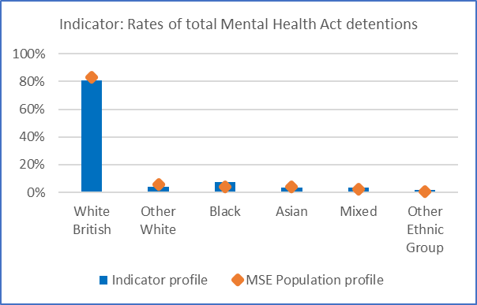Graph 2 shows rates of total Mental Health Act detentions by ethnic group, comparing the indicator profile against the MSE population profile, with white British being 80.6% compared to 83.21%, other white being 4% compared to 5.76%, black being 7.1% compared to 3.76%, Asian being 3.5% compared to 4.18%, mixed being 3.3% compared to 2.34% and lastly other ethnic group being 1.4% compared to the MSE population of 0.75%.

Graph 3: Rates of total Mental Health Act detentions – performance by gender

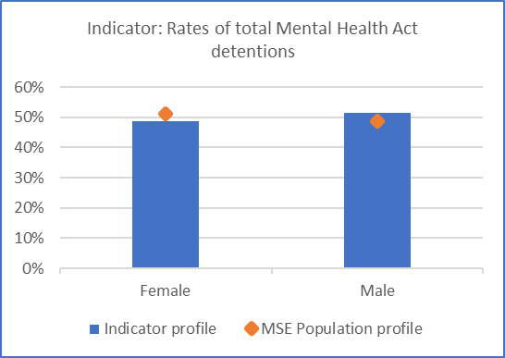Graph 3 shows rates of total Mental Health Act detentions by gender, comparing the indicator profile against the MSE population profile, with female being 48.7% compared to 51.2% and male being 51.3% compared to the MSE population of 48.8%.

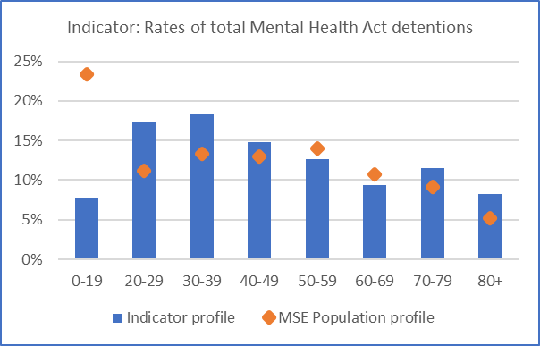Graph 4: Rates of total Mental Health Act detentions – performance by age

Graph 4 shows rates of total Mental Health Act detentions by age, comparing the indicator profile against the MSE population profile, with age range 0-19 being 7.8% compared to 23.4%, 20-29 being 17.3% compared to 11.2%, 30-39 being 18.4% compared to 13.3%, 40-49 being 14.8% compared to 13%, 50-59 being 12.6% compared to 14%, 60-69 being 9.4% compared to 10.7%, 70-79 being 11.5% compared to 9.2% and lastly 80 and over being 8.2%, compared to the MSE population of 5.2%.

**Observed health inequalities**

* Higher rates of detentions are seen in the more deprived areas, however 19.8% of patients had no postcode match or unknown postcode and therefore deprivation IMD could not be established.
* Performance by sex suggests to be somewhat similar to the MSE Population average, with Males performing just above the average.
* As in previous years, the detention rate nationally was highest among black or black British people in 2022-23 at 227.9 per 100,000 population, 3.5 times the rate for white people (64.1) (Source NHS Digital). MSE follows a similar pattern to that nationally, with a higher detention rate for black people compared to the local population profile.

**Action being taken to address these health inequalities**

* Further analysis is being undertaken to establish number of detentions under the Mental Health Act per 100,000 people, by aggregated ethnic group (standardised rates).
* Further identification of the demographics of those who are underrepresented, these groups will be targeted for engagement which might be informed by ethnicity, age, gender, or geographical location.
* Crisis Response NHS111(2) & CRT – Continued delivery, review, and refinement of an inclusive model to ensure early intervention to support reduction in waiting time for those detained under s136 from and detentions of under the MHA. Current s136 average of 9hrs to 6.5hrs. They have also seen a reduction in the volume of individuals we detain by 32% which equates to around 228 less detentions. To work with EPUT around MH act detention to elicit similar impact.
* Data represents patients not the instances of detentions or interventions, Apr23-Jan24.

*Source: EPUT Dataset – direct patient records*

**Indicator: Rates of restrictive interventions**

Graph 1: Rates of restrictive interventions – performance by deprivation quintile

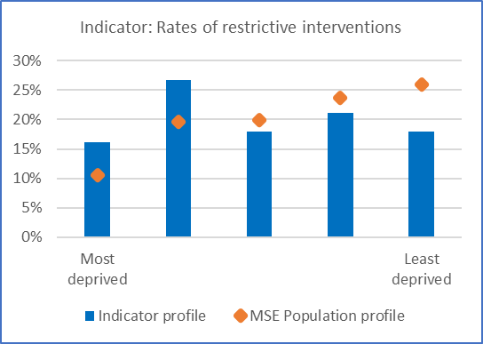Graph 1 shows rates of restrictive interventions by deprivation quintile, comparing the indicator profile against the MSE population profile, with quintile 1 (most deprived) being 16.1% compared to 10.6%, quintile 2 being 26.7% compared to 19.6%, quintile 3 being 18% compared to 20%, quintile 4 being 21.1% compared to 23.7% and lastly quintile 5 (least deprived) being 18% compared to the MSE population of 26%.

Graph 2: Rates of restrictive interventions – performance by ethnicity

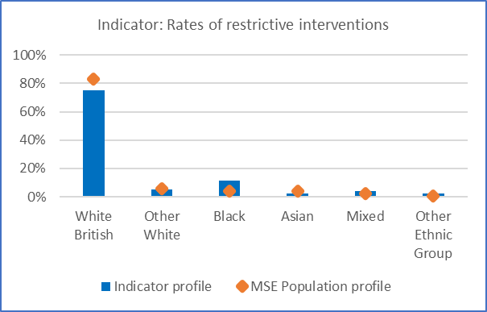Graph 2 shows rates of total Mental Health Act detentions by ethnic group, comparing the indicator profile against the MSE population profile, with white British being 75.4% compared to 83.21%, other white being 5% compared to 5.76%, black being 11.6% compared to 3.76%, Asian being 2% compared to 4.18%, mixed being 4% compared to 2.34% and lastly other ethnic group being 2% compared to the MSE population of 0.75%.

Graph 3: Rates of restrictive interventions – performance by gender

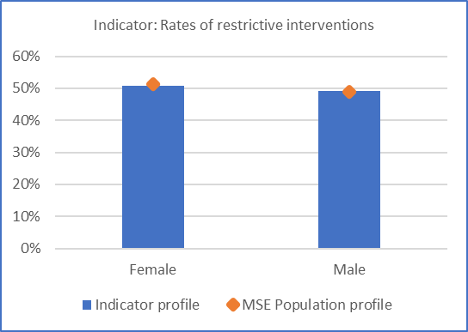Graph 3 shows rates of total Mental Health Act detentions by gender, comparing the indicator profile against the MSE population profile, with female being 50.7% compared to 51.2% and male being 49.3% compared to the MSE population of 48.8%.

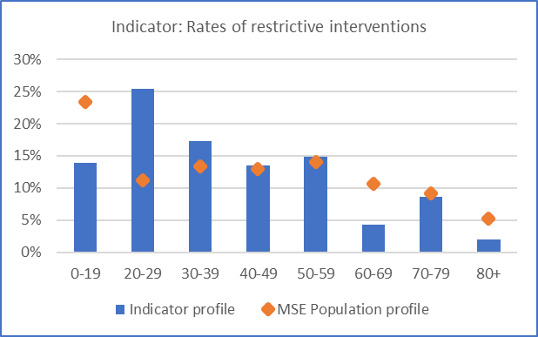Graph 4: Rates of restrictive interventions – performance by age

Graph 4 shows rates of restrictive interventions by age, comparing the indicator profile against the MSE population profile, with age range 0-19 being 13.9% compared to 23.4%, 20-29 being 25.5% compared to 11.2%, 30-39 being 17.3% compared to 13.3%, 40-49 being 13.5% compared to 13%, 50-59 being 14.9% compared to 14%, 60-69 being 4.3% compared to 10.7%, 70-79 being 8.7% compared to 9.2% and lastly 80 and over being 1.9%, compared to the MSE population of 5.2%.

**Observed health inequalities**

* Higher rates of restrictive interventions are seen in the more deprived areas, however 22.6% of patients had no postcode match or unknown postcode and therefore deprivation IMD could not be established.
* A quarter of restrictive interventions are in those aged 20-29 years.
* Black people are overrepresented with a higher proportion experiencing restrictive interventions compared to the MSE population profile.

**Action being taken to address these health inequalities**

* As part of the Mental Health Learning Disability and Autism inpatient quality programme, action is being taken on the following:
  + Reducing Restrictive Practice Strategy
  + Updating policies
  + Restrictive Practice awareness campaign to support staff in understanding the meaning of restrictive practice and its impact.
  + Engaging with experts by experience to support ward staff with training and development.
* Data represents patients not the instances of detentions or interventions, Apr23-Jan24.

*Source: EPUT Dataset – direct patient records*

**Indicator:** **NHS Talking Therapies (formerly IAPT) recovery**

Graph 1: NHS Talking Therapies (formerly IAPT) recovery – performance by ethnicity

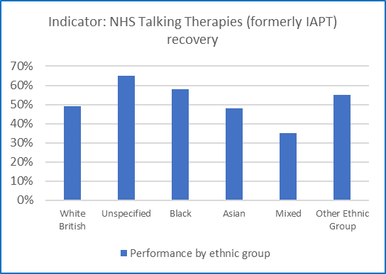Graph 1 shows NHS Talking Therapies (formerly IAPT) recovery performance by ethic group, with white British being 49%, unspecified being 65%, black being 58%, Asian being 48%, mixed being 35% and lastly other ethnic group being 55%.

Graph 2: NHS Talking Therapies (formerly IAPT) recovery – performance by gender

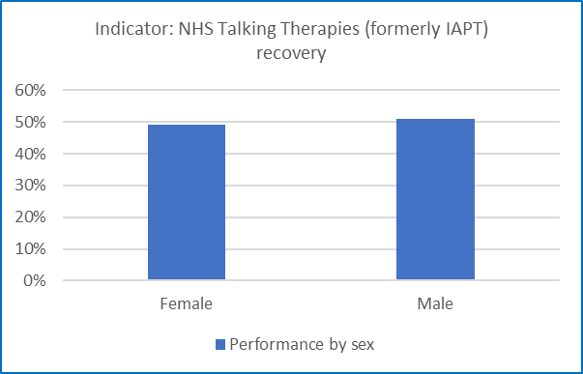Graph 2 NHS Talking Therapies (formerly IAPT) recovery performance by gender, with female being 49% and male being 51%.

Graph 3: NHS Talking Therapies (formerly IAPT) recovery – performance by age

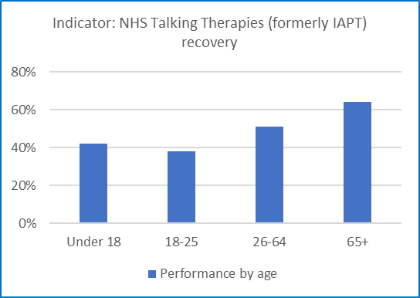Graph 3 NHS Talking Therapies (formerly IAPT) recovery performance by age, with those under 18 being 42%, 18-25 being 38%, 26-64 being 51%, and lastly 65 and over being 64%.

**Observed health inequalities**

* IAPT recovery is 15% lower for mixed ethnic groups than White British. Recovery rates for Black, other ethnic groups and those unspecified is significantly higher.
* Recovery rates are lower in the younger age groups, with those aged 25 years and below significantly below those aged 65 and over.

**Action being taken to address these health inequalities**

All four providers in MSE have:

* Communication and engagement plan with targeted outreach to inform people of the NHS Talking Therapies offer and to break down stigma regarding Mental Health
* Champion roles for clinicians to champion groups and work with them
* Review of Equality, Diversity, and Inclusion material for training purposes
* Engage in training offers and keep up to date with best practice guides for NHS Talking Therapies

*Source: NHS Talking Therapies Protected Characteristics Dashboard*

**Indicator: Children and young people’s mental health access**

Dashboard showing graphs


Image shows NELFT dashboard on Southend, Essex, and Thurrock CAMHS, including 4 tables displaying data on contacts | By method, with the first showing monthly data on video consultations, telephone consultations and face to face contacts. The second graph shows monthly data on ethnic group. The third graph shows monthly data on age ranges and lastly the fourth graph shows monthly data of gender.

**Observed health inequalities**

* The proportion of contacts where the ethnic background is not known has been increasing
* The proportion of contacts has been increasing in the younger age groups those 10-15 years, with proportionately fewer in those 16 years and above
* A significantly higher proportion of individual accessing the service are female, although this has been reducing over time.

**Action being taken to address these health inequalities**

* Prioritisation of the expansion of MHST teams for wave 11 includes mandated 8 EMHP’s as per NHSE guidance and aligned to the workforce model.
* Learning from previous waves has allowed us to think differently about roles within MHSTs, with a particular focus on recruitment and retention of the MHST workforce.
* The specific learning from previous MHST implementation has provided the opportunity to continue development of a workforce strategy and adapt this accordingly in line with the NHSE Improving Staff Retention Guide.
* The intention is that this will build evidence on closer collaboration between education and health, including working collaboratively across professional boundaries, training for non-health staff and creating environments that facilitate best possible outcomes for children and young people by primarily targeting the increasing identified age group of 10-15 years.

*Source: NELFT dataset*

## Domain: Cancer

**Indicator: Children and young people’s mental health access**

Graph 1: Percentage of cancers diagnosed at stage 1 and 2, case mix adjusted for cancer site, age at diagnosis and sex (2019- 2021)

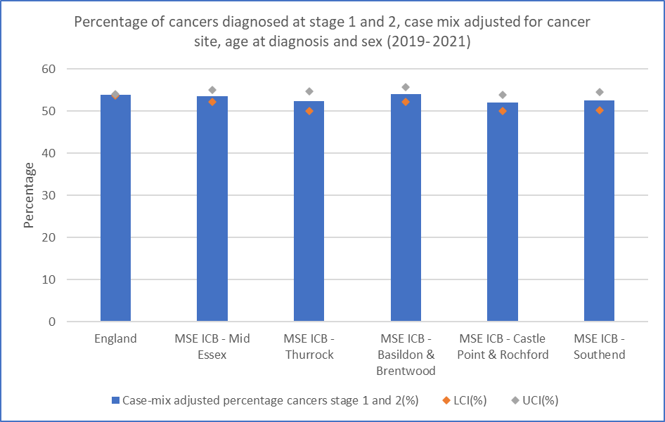

Graph 1 shows percentage of cancers diagnosed at stage 1 and 2, case mix adjusted for cancer site, age at diagnosis and sex (2019- 2021) showing England average Case-mix adjusted percentage cancers diagnosed at stage 1 and 2 as being 53.9% MSE ICB – Mid Essex’s Case-mix adjusted percentage cancers stage 1 and 2 being 53.6%. MSE ICB – Thurrock’s Case-mix adjusted percentage cancers stage 1 and 2 is 52.4%. MSE ICB – Basildon & Brentwood Case-mix adjusted percentage cancers stage 1 and 2 is 54%. MSE ICB – Castle Point & Rochford’s Case-mix adjusted percentage cancers stage 1 and 2 is 52%. MSE ICB – Southend’s Case-mix adjusted percentage cancers stage 1 and 2 is 52.5%.

**Observed health inequalities**

* MSE ICB has a lower proportion of cancers diagnosed at stage 1 and 2 in comparison to the England average
* There is variation between the localities in MSE with the highest proportion of cancers diagnosed at an early stage in Basildon and Brentwood.
* Lowest early cancer detection rates are in Castle Point and Rochford

**Action being taken to address these health inequalities**

* PCNs receive data on cancer screening uptake by deprivation and includes protected groups including patients with Learning Disabilities, ethnic groups, and patients with SMI.
* Opportunities for improvement in uptake are identified, support provided and information on best practice shared including tailored communication packages.
* Development and roll out of accessible information on cancer screening programmes for those with learning disabilities
* Development of culturally competent communication with videos from local doctors talking about how to recognise and identify the signs and symptoms of some of the most common cancers
* Expansion of lung cancer screening programme to Castle Point and Rochford following successful roll out in Thurrock and Southend

*Source: Cancer Registry staging data in three year cohorts*

## Domain: Cardiovascular disease

**Indicator: Stroke rate of non-elective admissions (per 100,000 age-sex standardised)**

Graph 1:  Stroke rate of non-elective admissions (per 100,000 age-sex standardised) – performance by deprivation quintile

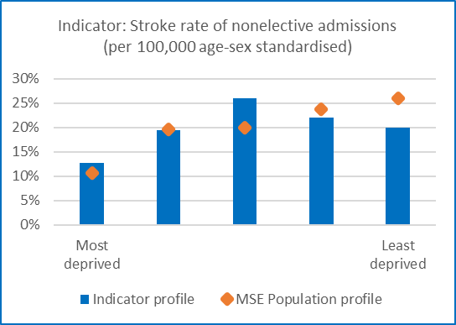Graph 1 shows stroke rate of non-elective admissions (per 100,000 age-sex standardised) by deprivation quintile, comparing the indicator profile against the MSE population profile, with quintile 1 (most deprived) being 12.6% compared to 10.6%, quintile 2 being 19.4% compared to 19.6%, quintile 3 being 25.9% compared to 20%, quintile 4 being 22% compared to 23.7% and lastly quintile 5 (least deprived) being 20% compared to the MSE population of 26%.

Graph 2:  Stroke rate of non-elective admissions (per 100,000 age-sex standardised) – performance by ethnicity

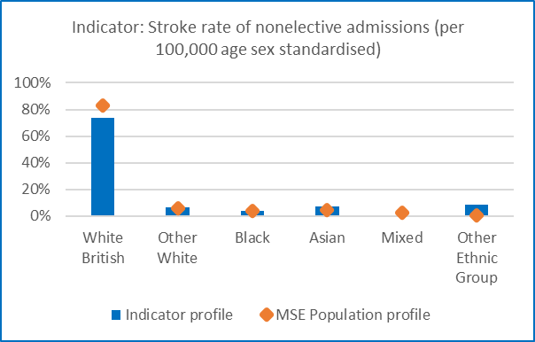Graph 2 shows stroke rate of non-elective admissions (per 100,000 age-sex standardised) by ethnic group, comparing the indicator profile against the MSE population profile, with white British being 73.4% compared to 83.21%, other white being 6.6% compared to 5.76%, black being 4.1% compared to 3.76%, Asian being 7% compared to 4.18%, mixed being 0.5% compared to 2.34% and lastly other ethnic group being 8.4% compared to the MSE population of 0.75%.

Graph 3:  Stroke rate of non-elective admissions (per 100,000 age-sex standardised) – performance by gender

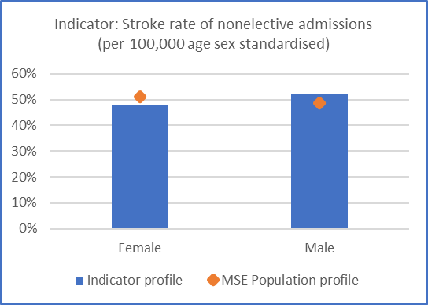Graph 3 shows stroke rate of non-elective admissions (per 100,000 age-sex standardised) by gender, comparing the indicator profile against the MSE population profile, with female being 47.7% compared to 51.2% and male being 52.3% compared to the MSE population of 48.8%.

Graph 4:  Stroke rate of non-elective admissions (per 100,000 age-sex standardised) – performance by age

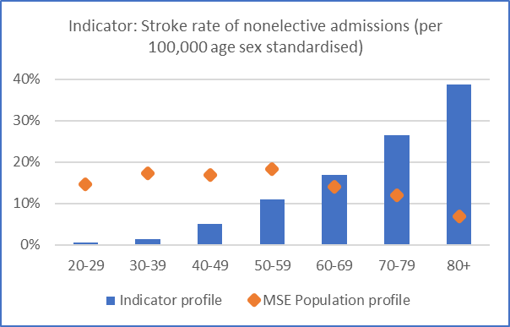Graph 4 shows stroke rate of non-elective admissions (per 100,000 age-sex standardised) by age, comparing the indicator profile against the MSE population profile, with age range 20-29 being 0.6% compared to 14.6%, 30-39 being 1.4% compared to 17.4%, 40-49 being 5% compared to 16.9%, 50-59 being 11% compared to 18.3%, 60-69 being 16.9% compared to 14%, 70-79 being 26.5% compared to 12% and lastly 80 and over being 38.7%, compared to the MSE population of 6.8%.

**Observed health inequalities**

* Reduced stroke rate of nonelective admissions (per 100,000 age-sex standardised) in least deprived group.
* Reduced stroke rate of nonelective admissions (per 100,000 age-sex standardised) in White British group.
* Reduced stroke rate of nonelective admissions (per 100,000 age-sex standardised) in Female, males over-represented.
* Age distribution does not reflect that of the MSE population with over representation in those over 60 years, but this is to be expected.

**Action being taken to address these health inequalities**

* These findings will be reviewed and considered in our MSE Stroke Network Meeting.

*Source: MSE local dataset – Athena*

**Indicator:** **Myocardial infarction – rate of non-elective admissions (per 100,000 age-sex standardised)**

Graph 1:  Myocardial infarction – rate of non-elective admissions (per 100,000 age-sex standardised)– performance by deprivation quintile

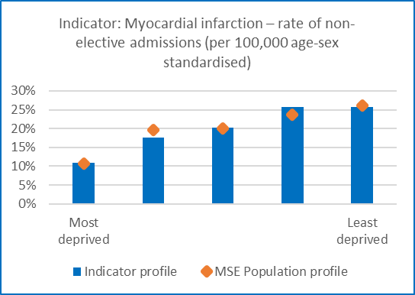 Graph 1 shows Myocardial infarction – rate of non-elective admissions (per 100,000 age-sex standardised) by deprivation quintile, comparing the indicator profile against the MSE population profile, with quintile 1 (most deprived) being 10.8% compared to 10.6%, quintile 2 being 17.6% compared to 19.6%, quintile 3 being 20.3% compared to 20%, quintile 4 being 25.7% compared to 23.7% and lastly quintile 5 (least deprived) being 25.7% compared to the MSE population of 26%.

Graph 2:  Myocardial infarction – rate of non-elective admissions (per 100,000 age-sex standardised)– performance by ethnicity

Graph 2 shows Myocardial infarction – rate of non-elective admissions (per 100,000 age-sex standardised), comparing the indicator profile against the MSE 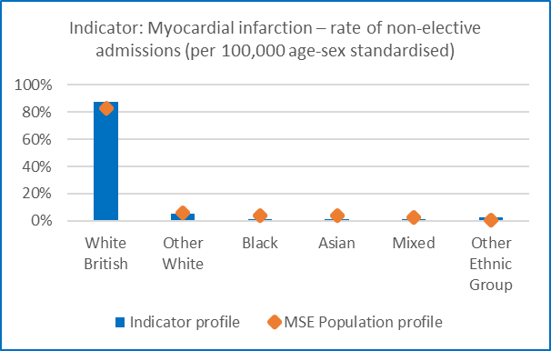population profile, with white British being 87.5% compared to 83.21%, other white being 5.6% compared to 5.76%, black being 1.4% compared to 3.76%, Asian being 1.4% compared to 4.18%, mixed being 1.4% compared to 2.34% and lastly other ethnic group being 2.8% compared to the MSE population of 0.75%.

Graph 3:  Myocardial infarction – rate of non-elective admissions (per 100,000 age-sex standardised)– performance by gender

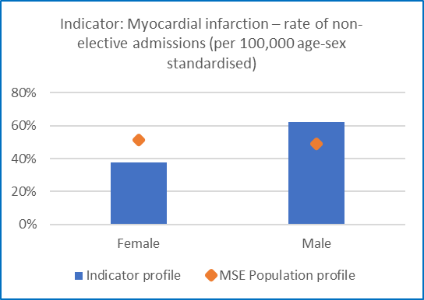Graph 3 shows Myocardial infarction – rate of non-elective admissions (per 100,000 age-sex standardised) by gender, comparing the indicator profile against the MSE population profile, with female being 37.8% compared to 51.2% and male being 62.2% compared to the MSE population of 48.8%.

Graph 4:  Myocardial infarction – rate of non-elective admissions (per 100,000 age-sex standardised)– performance by age

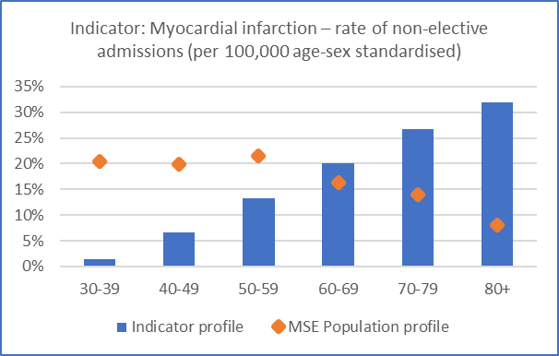Graph 4 shows Myocardial infarction – rate of non-elective admissions (per 100,000 age-sex standardised) by age, comparing the indicator profile against the MSE population profile, with age range 30-39 being 1.3% compared to 20%, 40-49 being 6.7% compared to 20%, 50-59 being 13.3% compared to 21%, 60-69 being 20% compared to 16%, 70-79 being 26.7% compared to 14% and lastly 80 and over being 32%, compared to the MSE population of 8%.

**Observed health inequalities**

* Rate of non-elective admissions by ethnicity is similar to MSE’s population profile with the expectation of those of Black, Asian, and mixed backgrounds whose admission rates are lower.
* Profile by sex highlights higher admission rate in Males compared to the MSE population profile.
* Age distribution does not reflect that of the MSE population with over representation in those over 60 years, but this is to be expected.
* MI rates of non-elective admissions (per 100,000 age-sex standardised) broadly map to population deprivation profile and ethnic profiles.
* Gender analysis shows higher rates of MI non-elective admissions in males compared to population proportion than females.

**Action being taken to address these health inequalities**

* MSE’s CVD Prevention Programme focuses on key Cardiovascular priorities of hypertension and lipids with the aim of increasing opportunities for early identification and intervention to reduce further risk of heart attack or stroke.
* CVD identified as the focus for the MSE Community Provider collaboratives: Improving equitably - Peer learning and coaching programme.
* CVD Board will review analysis and be discussed amongst partners including MSEFT.

*Source: MSE local dataset – Athena*

**Indicator: Percentage of patients aged 18 and over, with GP recorded hypertension, in whom the last blood pressure reading (measured in the preceding 12 months) is below the age-appropriate treatment threshold**

Graph 1:  Percentage of patients aged 18 and over, with GP recorded hypertension, in whom the last blood pressure reading (measured in the preceding 12 months) is below the age-appropriate treatment threshold – performance by deprivation quintile

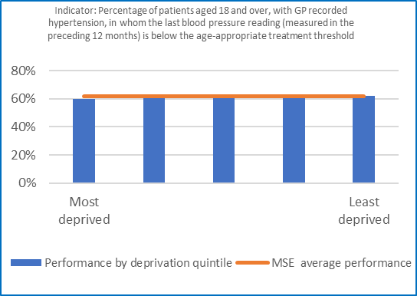Graph 1 shows Percentage of patients aged 18 and over, with GP recorded hypertension, in whom the last blood pressure reading (measured in the preceding 12 months) is below the age-appropriate treatment threshold performance by deprivation quintile, with quintile 1 (most deprived) being 60%, quintile 2 being 61%, quintile 3 being 63%, quintile 4 being 63% and lastly quintile 5 (least deprived) being 62%, comparative to the MSE average performance of 62%.

Graph 2:  Percentage of patients aged 18 and over, with GP recorded hypertension, in whom the last blood pressure reading (measured in the preceding 12 months) is below the age-appropriate treatment threshold – performance by ethnicity

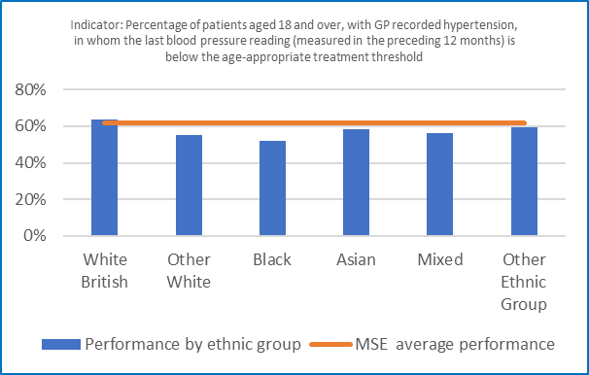Graph 2 shows Percentage of patients aged 18 and over, with GP recorded hypertension, in whom the last blood pressure reading (measured in the preceding 12 months) is below the age-appropriate treatment threshold performance by ethnic group, with white British being 63.6%, other white being 55.4%, black being 51.9.5%, Asian being 58.2%, mixed being 56.4% and lastly other ethnic group being 59.2%, comparative to the MSE average performance of 62%.

Graph 3:  Percentage of patients aged 18 and over, with GP recorded hypertension, in whom the last blood pressure reading (measured in the preceding 12 months) is below the age-appropriate treatment threshold – performance by gender

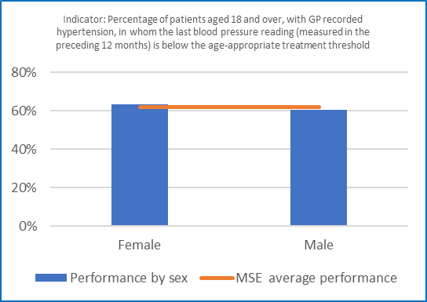Graph 3 shows the Percentage of patients aged 18 and over, with GP recorded hypertension, in whom the last blood pressure reading (measured in the preceding 12 months) is below the age-appropriate treatment threshold performance by gender, with female being 63.5% and male being 60.5%, comparative to the MSE average performance of 62%.

Graph 4:  Percentage of patients aged 18 and over, with GP recorded hypertension, in whom the last blood pressure reading (measured in the preceding 12 months) is below the age-appropriate treatment threshold – performance by age

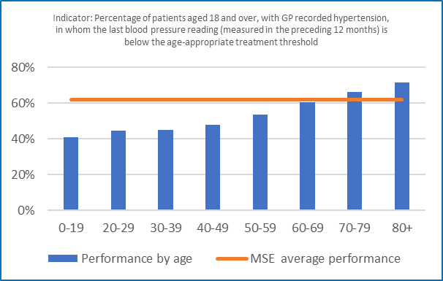Graph 4 shows the Percentage of patients aged 18 and over, with GP recorded hypertension, in whom the last blood pressure reading (measured in the preceding 12 months) is below the age-appropriate treatment threshold performance by age, with age range 0-19 being 40.9%, 20-29 being 44.6%, 30-39 being 45.1%, 40-49 being 47.7%, 50-59 being 53.7%, 60-69 being 60.5%, 70-79 being 66% and lastly 80 and over being 71.3%, comparative to the MSE average performance of 62%.

**Observed health inequalities**

* Performance does not significantly vary by deprivation or sex.
* Performance by ethnic group highlights that other than White British, other ethnic groups have a higher proportion of patients not managed to treatment thresholds with the highest underrepresented being those from a Black ethnic group.
* Performance by age group indicates we are currently performing significantly below MSE Population average for all age groups under 60 with only those ages 70-79 and 80+ performing above average.

**Action being taken to address these health inequalities**

* Introducing an MSE pilot BP@home Health Inequalities Extension, targeting practices within the 20% most deprived areas with the highest levels of CVD risk, providing BP monitors to patients within plus groups/unable to afford to purchase their own to tackle health inequalities relating to home blood monitoring.
* MSE is developing a BP in the Community pilot which will look to case find potential hypertension amongst Plus groups and those less likely to be engaged with health care services, taking a community outreach approach.
* Hypertension is also an area of focus within the Mid and South Essex CVD Local Enhanced Service (LES), identifying patients living in the 20% most deprived areas and uses the UCLP risk stratification tool medium risk patents on multiple disease registers. As part of the scheme, practices are encouraged to focus on specific cohorts of patients with hypertension including Black and South Asian Ethnic groups.

*Source: MSE local dataset – Athena*

**Indicator:** **Percentage of patients aged 18 and over with no GP recorded CVD and a GP recorded QRISK score of 20% or more, on lipid lowering therapy**

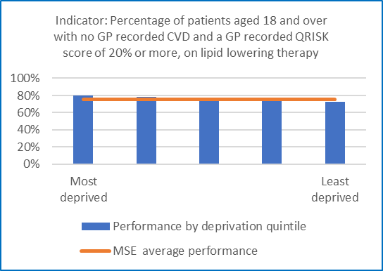Graph 1:  Percentage of patients aged 18 and over with no GP recorded CVD and a GP recorded QRISK score of 20% or more, on lipid lowering therapy – performance by deprivation quintile

Graph 1 shows Percentage of patients aged 18 and over with no GP recorded CVD and a GP recorded QRISK score of 20% or more, on lipid lowering therapy by deprivation quintile, with quintile 1 (most deprived) being 80%, quintile 2 being 79%, quintile 3 being 76%, quintile 4 being 75% and lastly quintile 5 (least deprived) being 73%, comparative to the MSE average performance of 75.6%.

Graph 2:  Percentage of patients aged 18 and over with no GP recorded CVD and a GP recorded QRISK score of 20% or more, on lipid lowering therapy – performance by ethnicity

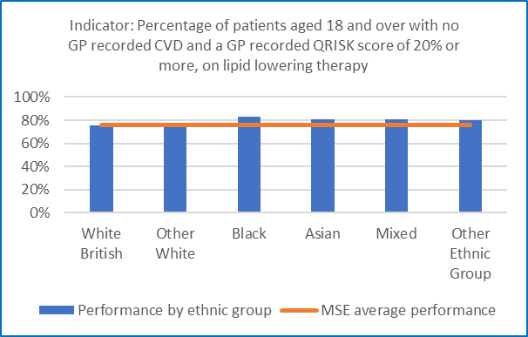Graph 2 shows Percentage of patients aged 18 and over with no GP recorded CVD and a GP recorded QRISK score of 20% or more, on lipid lowering therapy performance by ethnic group, with white British being 75.5%, other white being 76.4%, black being 83.1%, Asian being 80.8%, mixed being 80.5% and lastly other ethnic group being 80.1%, comparative to the MSE average performance of 75.6%.

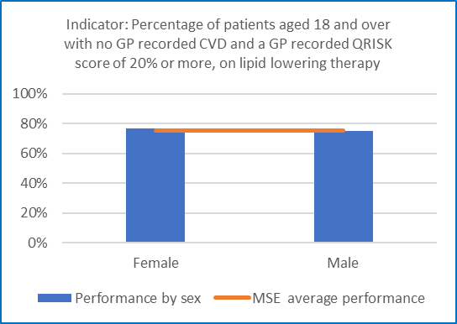Graph 3:  Percentage of patients aged 18 and over with no GP recorded CVD and a GP recorded QRISK score of 20% or more, on lipid lowering therapy – performance by gender

Graph 3 shows the Percentage of patients aged 18 and over with no GP recorded CVD and a GP recorded QRISK score of 20% or more, on lipid lowering therapy performance by gender, with female being 76.9% and male being 74.8%, comparative to the MSE average performance of 75.6%.

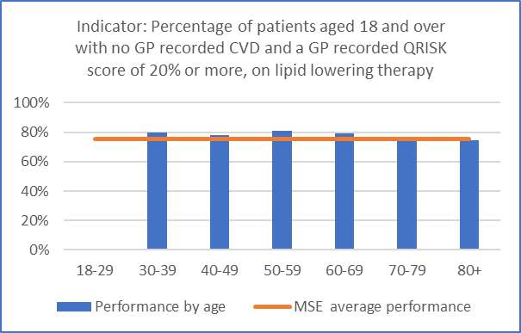Graph 4:  Percentage of patients aged 18 and over with no GP recorded CVD and a GP recorded QRISK score of 20% or more, on lipid lowering therapy – performance by age

Graph 4 shows the Percentage of patients aged 18 and over with no GP recorded CVD and a GP recorded QRISK score of 20% or more, on lipid lowering therapy performance by age, with age range 18-29 being 0%, 30-39 being 80%, 40-49 being 78.2%, 50-59 being 81.2%, 60-69 being 79%, 70-79 being 74.6% and lastly 80 and over being 74.8%, comparative to the MSE average performance of 75.6%.

**Observed health inequalities**

* Performance does not significantly vary by deprivation or sex.
* Performance by ethnic group indicates performance is somewhat similar to the MSE population average, with Black, Asian, Mixed and Other Ethnic Groups all performing above the average.
* Performance by age group indicates performance is somewhat similar to the MSE Population average with those age 70-79 and 80+ being slightly below average. There are no patients within age groups 0-19 and 20-29.

**Action being taken to address these health inequalities**

* MSE have introduced a Lipid QOF Extension, offered to practices identifying with the highest CVD need within the most deprived areas. This incentives practices to increase the % of patients that are optimising lipid lowering therapy.

*Source: MSE local dataset – Athena*

**Indicator:** **Percentage of patients aged 18 and over with GP recorded atrial fibrillation and a record of a CHA2DS2-VASc score of 2 or more, who are currently treated with anticoagulation drug therapy**

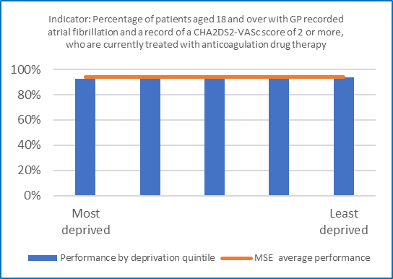Graph 1:  Percentage of patients aged 18 and over with GP recorded atrial fibrillation and a record of a CHA2DS2-VASc score of 2 or more, who are currently treated with anticoagulation drug therapy – performance by deprivation quintile

Graph 1 shows the Percentage of patients aged 18 and over with GP recorded atrial fibrillation and a record of a CHA2DS2-VASc score of 2 or more, who are currently treated with anticoagulation drug therapy performance by deprivation quintile, with quintile 1 (most deprived) being 93%, quintile 2 being 93%, quintile 3 being 94%, quintile 4 being 94% and lastly quintile 5 (least deprived) being 94%, comparative to the MSE average performance of 93.8%.

Graph 2:  Percentage of patients aged 18 and over with GP recorded atrial fibrillation and a record of a CHA2DS2-VASc score of 2 or more, who are currently treated with anticoagulation drug therapy – performance by ethnicity

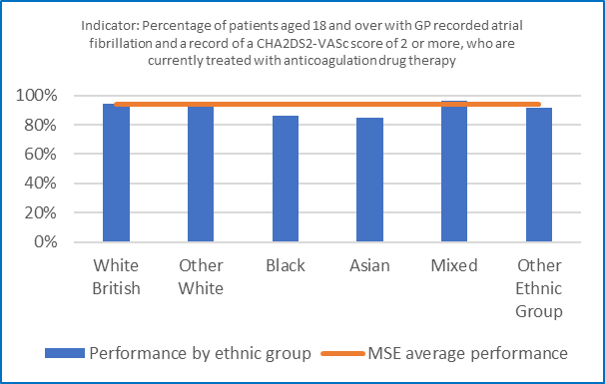Graph 2 the Percentage of patients aged 18 and over with GP recorded atrial fibrillation and a record of a CHA2DS2-VASc score of 2 or more, who are currently treated with anticoagulation drug therapy performance by ethnic group, with white British being 94.1%, other white being 93.8%, black being 86.4%, Asian being 84.7%, mixed being 96.4% and lastly other ethnic group being 91.1%, comparative to the MSE average performance of 93.8%.

Graph 3:  Percentage of patients aged 18 and over with GP recorded atrial fibrillation and a record of a CHA2DS2-VASc score of 2 or more, who are currently treated with anticoagulation drug therapy – performance by gender

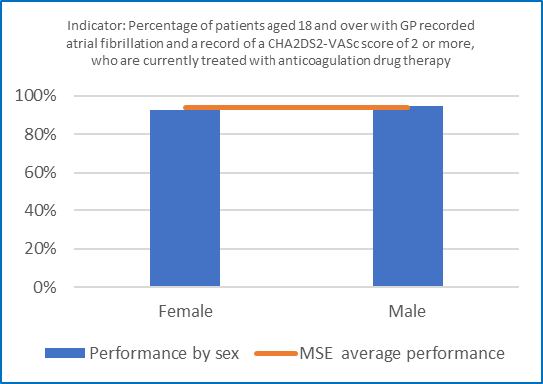Graph 3 shows the Percentage of patients aged 18 and over with GP recorded atrial fibrillation and a record of a CHA2DS2-VASc score of 2 or more, who are currently treated with anticoagulation drug therapy performance by gender, with female being 92.6% and male being 94.9%, comparative to the MSE average performance of 94%.

Graph 4:  Percentage of patients aged 18 and over with GP recorded atrial fibrillation and a record of a CHA2DS2-VASc score of 2 or more, who are currently treated with anticoagulation drug therapy – performance by age

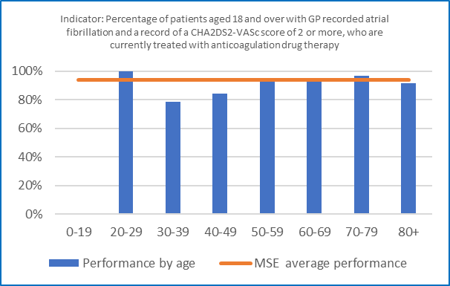Graph 4 shows the Percentage of patients aged 18 and over with GP recorded atrial fibrillation and a record of a CHA2DS2-VASc score of 2 or more, who are currently treated with anticoagulation drug therapy performance by age, with age range 0-19 being 0%, 20-29 being 100%, 30-39 being 78.6%, 40-49 being 84.5%, 50-59 being 94.1%, 60-69 being 94.5%, 70-79 being 96.7% and lastly 80 and over being 94%, comparative to the MSE average performance of 94%.

**Observed health inequalities**

* Performance does not significantly vary by deprivation or sex.
* Performance by ethnic groups highlights performance amongst Black and Asian ethnic groups to be relatively lower than the MSE Population average with all other groups performing somewhat similar.
* Performance by age group shows age group 20-29 to be exceeding the MSE Population average whilst age groups 30-39- 40-49 to be performing significantly under the average rate. All other age groups are performing somewhat in line of the average.

**Action is being taken to address these health inequalities**

* MSE BP in the Community programme supports further case finding for hypertension amongst Plus groups and those less likely to engage with health care services by taking a community outreach approach
* MSE have identified the opportunity to carry out AF case finding to further support to identify undiagnosed or unmanaged cases of AF.

*Source: MSE local dataset – Athena*

## Domain: Diabetes

**Indicator: Percentage of people with Type 1 receiving all 8 care processes**

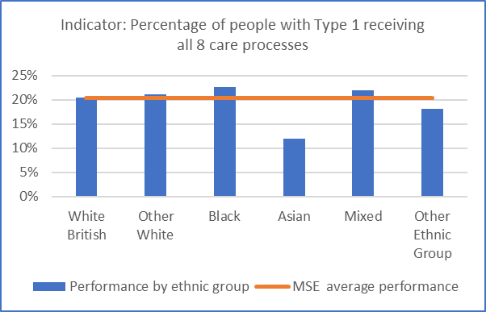Graph 1:  Percentage of people with Type 1 receiving all 8 care processes – performance by ethnicity

Graph 2 the Percentage of people with Type 1 receiving all 8 care processes performance by ethnic group, with white British being 20.5%, other white being 21.1%, black being 22.7%, Asian being 11.9%, mixed being 21.9% and lastly other ethnic group being 18.2%, comparative to the MSE average performance of 20.3%.

Graph 2:  Percentage of people with Type 1 receiving all 8 care processes – performance by gender

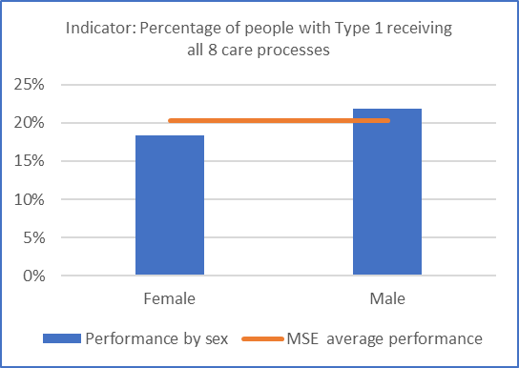Graph 2 shows the Percentage of people with Type 1 receiving all 8 care processes performance by gender, with female being 18.3% and male being 21.9%, comparative to the MSE average performance of 20.3%.

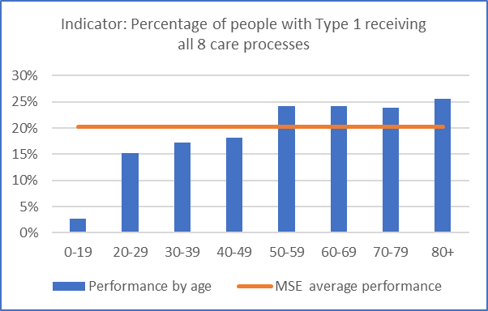Graph 3:  Percentage of people with Type 1 receiving all 8 care processes – performance by age

Graph 3 shows the Percentage of people with Type 1 receiving all 8 care processes performance by age, with age range 0-19 being 2.7%, 20-29 being 15.2%, 30-39 being 17.3%, 40-49 being 18.1%, 50-59 being 24.2%, 60-69 being 24.1%, 70-79 being 23.9% and lastly 80 and over being 25.5%, comparative to the MSE average performance of 20.3%.

**Observed health inequalities**

* Health inequalities analysis regarding deprivation has yet to be completed for the people with Type 1 receiving all 8 care processes
* There is a higher proportion of people from a black or mixed background receiving all 8 care processes. People from an Asian ethnicity background are less likely to have received all 8 care processes.
* A higher proportion of males have received all 8 care processes
* Those over 50 years are more likely to have received all 8 care processes.

*Source: MSE local data set Athena*

**Indicator: Percentage of people with Type 2 receiving all 8 care processes**

Graph 1:  Percentage of people with Type 2 receiving all 8 care processes – performance by ethnicity

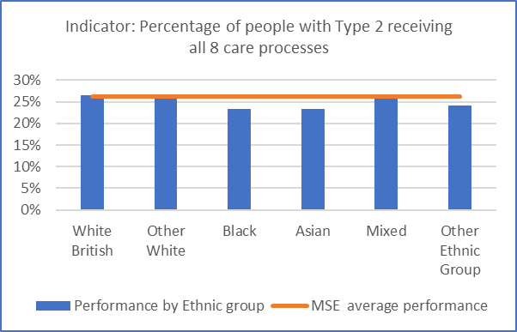Graph 1 the Percentage of people with Type 2 receiving all 8 care processes performance by ethnic group, with white British being 26.5%, other white being 26.8%, black being 23.3%, Asian being 23.3%, mixed being 26.4% and lastly other ethnic group being 24.1%, comparative to the MSE average performance of 26.2%.

Graph 2:  Percentage of people with Type 2 receiving all 8 care processes – performance by gender

Graph 2 shows the Percentage of people with Type 2 receiving all 8 care processes performance by gender, with female being 25.1% and male being 27.3%, comparative to the MSE average performance of 26.2%.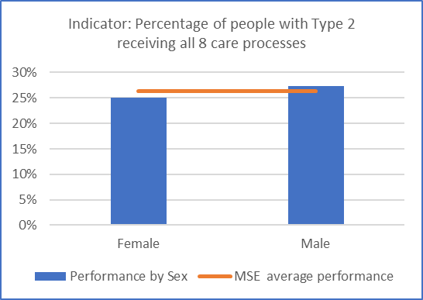

Graph 3:  Percentage of people with Type 2 receiving all 8 care processes – performance by age

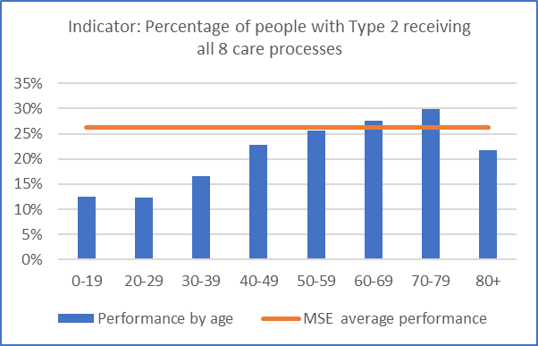Graph 3 shows the Percentage of people with Type 2 receiving all 8 care processes performance by age, with age range 0-19 being 12.5%, 20-29 being 12.4%, 30-39 being 16.6%, 40-49 being 22.8%, 50-59 being 25.7%, 60-69 being 27.7%, 70-79 being 29.9% and lastly 80 and over being 21.6%, comparative to the MSE average performance of 26.2%.

**Observed health inequalities**

* Health inequalities analysis regarding deprivation has yet to be completed for the people with Type 2 receiving all 8 care processes
* There is a higher proportion of people from a black or mixed ethnic background receiving all 8 care processes. People from other ethnic groups are less likely to have received all 8 care processes.
* A higher proportion of males have received all 8 care processes
* Those over 50 years are more likely to have received all 8 care processes.

*Source: MSE local data set Athena*

**Indicator: Percentage of people with Type 1 and 2 receiving all 8 care processes**

**Action being taken to address these health inequalities**

To improve the % of people with Type 1 and 2 receiving all eight care processes MSE ICB has:

* Introduced care bundle test requesting in the pathology and radiology system (ICE) which means with a single click all Diabetes tests (hba1C, Creatinine, cholesterol, urine ACR) can be requested in the system without missing any tests.
* Monthly Eclipse training for the past year on how to use data to improve diabetes care. Eclipse is a data support tool that assists GP Practices in optimising treatment for patients.
* Regular monthly reporting at an Alliance and Practice level is undertaken to identify opportunities for improvements in performance.
* Educational training and supported has been delivered via “Time to learn” sessions, through existing Clinical leadership meetings (CLef), lunch and learn and evening GP sessions
* Standardise data capture and ensure consistency of processes through the utilisation of a Diabetes template in Ardens.
* Development of a Diabetes Dashboard that enables primary care to access data and ability to reidentify patients will become available for practices to target patients.
* Currently reviewing the award winning PARM tool, a health management tool for people with diabetes, to assess whether it can be used in MSE to risk assess patients.
* Funding given to Community Collaborative to support 2 PCNs, Southend Victoria PCN and Tilbury and Chadwell PCN, to improve 8 Care process during 2023/24. As at Mid-December nearly 600 patients have now had the care processes reviewed and captured. A one stop Foot and Retinopathy screen is also being trialled in one of the PCNs. The evaluation will be completed during 2024/25 and good practice and learnings spread across MSE.
* Implementation of the ‘T2Day: Type 2 Diabetes in the Young’ programme where patients benefit from extra one-to-one reviews as well as the option of new medicines and treatments where indicated, to help better manage their diabetes
* Planning Diabetes case finding trial in practice to roll out in MSE. This will alert practices to code 2 abnormal high HBA1C as Diabetes.
* All providers with MSE have been challenged to target resources in areas facing health inequalities including in areas of deprivation.

**Indicator: Variation between % of referrals from the most deprived quintile and % of Type 2 diabetes population from the most deprived quintile**

Graph 1: Framework 2 contract (Dec2020-Nov2023): Index of Multiple Deprivation (IMD) demographic of patient referrals & of programme starters (MS1) vs local type 2 diabetes prevalence

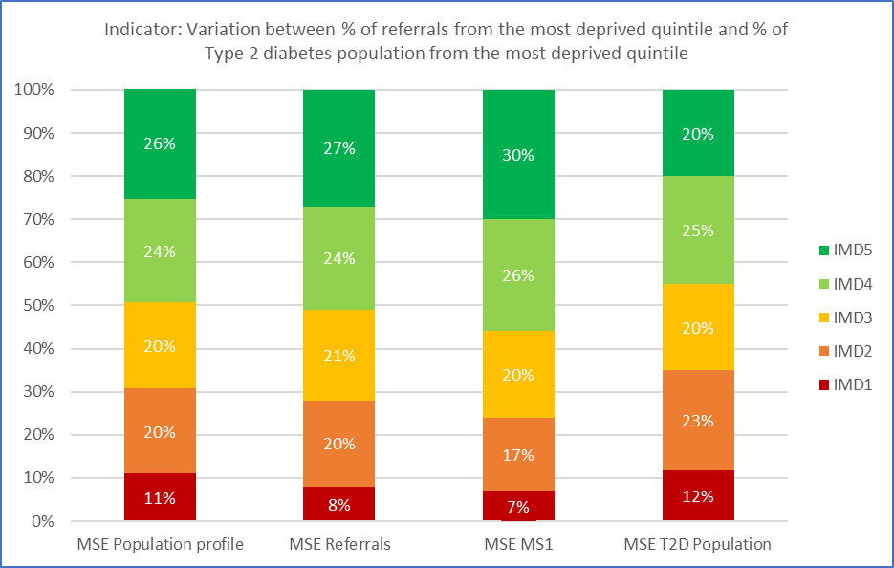

Graph 1 shows Variation between % of referrals from the most deprived quintile and % of Type 2 diabetes population from the most deprived quintile, with MSE Population profile having 26% in IMD5, 24% in IMD4, 20% in IMD3, 20% in IMD2 and 11% in IMD1. For MSE referrals 27% are in IMD5, 24% in IMD4, 21% in IMD3, 20% in IMD2 and 8% in IMD1. For MSE MS1 30% are in IMD5, 26% in IMD4, 20% in IMS3, 17% in IMS2 and 7% in IMD1. MSE Type 2 diabetes population 20% are in IMD5, 25% in IMD4, 20% in IMD3, 23% in IMD2 and lastly 12% in IMD1.

**Observed health inequalities**

* Referrals into the National Diabetes Prevention Programme (NDPP) are closely representative of the MSE population profile
* The number of programme starters is higher in the least deprived areas (IMD4 and IMD5) with proportionally lower numbers from the most deprived backgrounds (IMD1 and IMD2) which is an under representation of the type 2 diabetes prevalence for these groups.

**Action is being taken to address these health inequalities**

* PCN level data shared identifying those PCNs where % of referrals for people in IMD1 has not matched local T2D prevalence.
* Engagement with PCN lead GPs and Ops manager understand barriers to making referrals.
* Training and awareness sessions undertaken with PCN staff (focused on ARRS roles) on how to refer to NDPP
* Communication and promotion materials for NDPP developed and available on MSE Primary Care Hub
* Lunch n Learn webinars regularly delivered by the new service provider Xyla Health & Wellbeing.

Free Continuing Professional Development accredited training on non-diabetic hyperglycaemia testing, Type 2 Diabetes risk factors and the NDPP from Royal College General Practitioners and Primary Care Diabetes Society

*Source: National Diabetes Prevention Programme Dashboard*

## Domain: Smoking Cessation

**Indicator: Proportion of adult acute inpatient settings offering smoking cessation services**

**Action being taken to address health inequalities**

A smoking cessation in-house service is currently available across all wards in Basildon and Broomfield Hospitals and will be in all wards in Southend Hospital by March 2024. The service engages with smokers who are an adult acute in-patient regardless of home address, ethnicity, socio-economic status, or any other criteria. The service has access to a translation service should patient who does not use English as their first language require support. The service is available to all, except for those who are under the age of 18 and not an inpatient.

Mid and South Essex NHS Foundation Trust are procuring a data collection, management, and reporting solution for Smoking Services. Whilst some data is currently collected it is incomplete so once there is a comprehensive dataset available in 2024/25 an assessment will be undertaken to identify if there are any inequalities to accessing the service and address as required.

**Indicator: Proportion of maternity inpatient settings offering smoking cessation services**

**Action being taken to address health inequalities**

MSE Maternity launched a full in-house smoking cessation service on 05/02/2024 across the three hospital sites: Basildon, Broomfield, and Southend. Providing women divulge their smoking status, electronic reports are set up to capture the personal details of all birthing people who ‘currently smoke’ and those who have ‘quit since conception.’ All women and birthing people within this category receive a telephone call during the next working day irrespective of their postcode and or deprivation level. Once we have several months data, analysis will be completed to determine if there is any correlation with opt out and areas of deprivation or inequalities. Targeted work will be undertaken to address health inequalities that may be identified.

## Domain: Oral Health

**Indicator:** **Tooth extractions due to decay for children admitted as inpatients to hospital, aged 10 years and under**

Graph 1: Tooth extractions due to decay for children admitted as inpatients to hospital, aged 10 years and under – performance by deprivation quintile

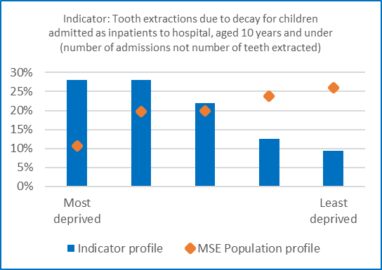Graph 1 shows Tooth extractions due to decay for children admitted as inpatients to hospital, aged 10 years and under by deprivation quintile, comparing the indicator profile against the MSE population profile, with quintile 1 (most deprived) being 28.1% compared to 10.6%, quintile 2 being 28.1% compared to 19.6%, quintile 3 being 21.9% compared to 20%, quintile 4 being 12.5% compared to 23.7% and lastly quintile 5 (least deprived) being 9.4% compared to the MSE population of 26%.

Graph 2: Tooth extractions due to decay for children admitted as inpatients to hospital, aged 10 years and under – performance by ethnicity

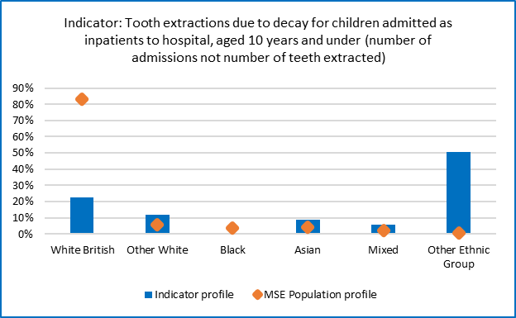Graph 2 shows Tooth extractions due to decay for children admitted as inpatients to hospital, aged 10 years and under by ethnicity, comparing the indicator profile against the MSE population profile, with white British being 22.4% compared to 83.21%, other white being 11.9% compared to 5.76%, black being 0% compared to 3.76%, Asian being 9% compared to 4.18%, mixed being 6% compared to 2.34% and lastly other ethnic group being 50.7% compared to the MSE population of 0.75%.

Graph 3: Tooth extractions due to decay for children admitted as inpatients to hospital, aged 10 years and under – performance by gender

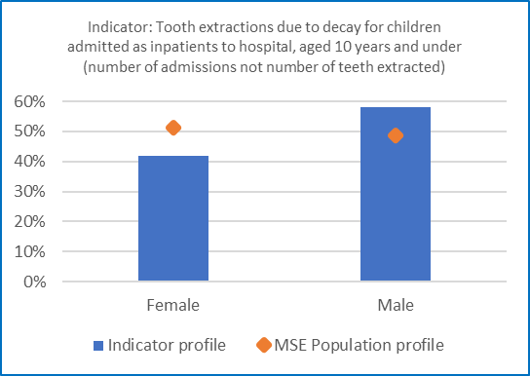Graph 3 shows Tooth extractions due to decay for children admitted as inpatients to hospital, aged 10 years and under by gender, comparing the indicator profile against the MSE population profile, with female being 41.8% compared to 51.2% and male being 58.2% compared to the MSE population of 48.8%.

**Observed health inequalities**

* Tooth decay is almost entirely preventable, yet tooth decay is the number one cause of admission to hospital for 5-9yrs old children.
* MSE has a disproportionate over representation of children having teeth removed in a hospital setting who live in areas of deprivation. This trend is seen nationally where decay-related tooth extraction rates are nearly 3.5 times higher for children living in the most deprived areas compared to more affluent areas.
* The ethnicity profile is currently being reviewed as data quality discrepancies have been identified regarding ethnicity recoding for children
* A higher proportion of boys have tooth extractions

**Action being taken to address these health inequalities**

A MSE ICP collaborative approach is being taken to accelerate oral health prevention:

* Use a data informed approach to drive activities in areas of highest need, development of a dashboard to track progress on child oral health. We currently planning on how to analysis waiting list data consistently across providers to identify inequality gaps and implement mitigating actions.
* Embed oral health preventative activities within wider system CYP policies and programs – in 2022/23 we committed health inequalities fundings to implement supervised toothbrushing schemes within two of our four place Alliances. For 24/25 this program is being spread across the remaining two Alliances. Additionally, Southend City Council are planning to extend supervised toothbrushing into school settings.
* Using the Core20PLUS5 approach we have identified our priority PLUS groups as to SEND, LAC, Deprivation, Refugees, Asylum Seekers & Migrants; deliver more targeted oral health prevention areas. In addition, we are working with commissioners to increase access to dental services including identification of dentists prioritising access for LAC and ensuring children are considered in our dental care access pilot.
* MSE has been selected as NHSE CYP Transformation pilot site which aims to test and develop a suite of evidence-based interventions. This program will work with the Family Hubs in Thurrock to enhance early years services with a consistent oral health promotion theme running through.
* Create widespread awareness of oral health promoting practices. This will be through resident facing communications and through early years workforce training

*Source: MSE local dataset – Athena*

## Domain: Learning disability and autistic people

**Indicator:** **Learning Disability Annual Health Checks**

Graph 1: Learning Disability Annual Health Checks – performance by deprivation quintile

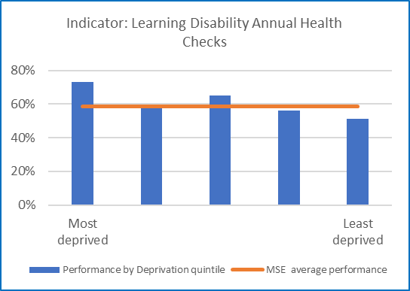Graph 1 shows Learning Disability Annual Health Checks performance by deprivation quintile, with quintile 1 (most deprived) being 72.9%, quintile 2 being 57.9%, quintile 3 being 65%, quintile 4 being 56.1% and lastly quintile 5 (least deprived) being 51%, comparative to the MSE average performance of 58.4.6%.

Graph 2: Learning Disability Annual Health Checks – performance by ethnicity

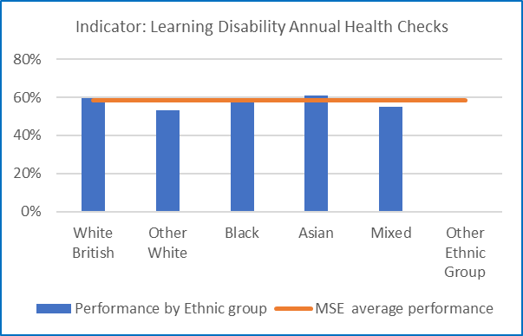Graph 2 shows Learning Disability Annual Health Checks performance by ethnic group, with white British being 59.7%, other white being 53.2%, black being 58.7%, Asian being 60.7%, mixed being 55.1% and lastly other ethnic group being 0%, comparative to the MSE average performance of 58.4%.

Graph 3: Learning Disability Annual Health Checks – performance by gender

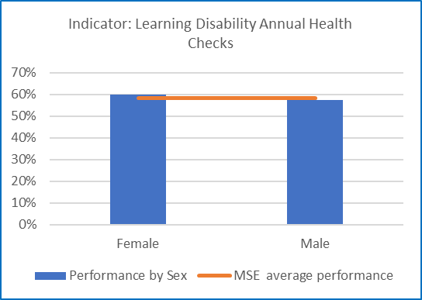Graph 3 shows Learning Disability Annual Health Checks performance by gender, with female being 59.8.4% and male being 57.5%, comparative to the MSE average performance of 58.4%.

Graph 4: Learning Disability Annual Health Checks – performance by age

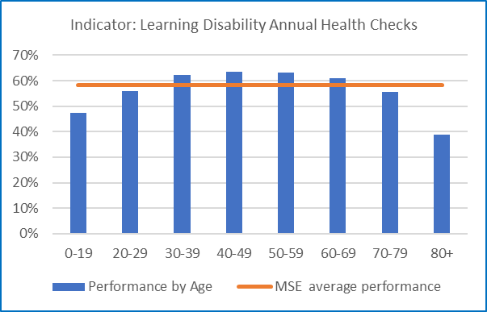Graph 4 shows Learning Disability Annual Health Checks performance by age, with age range 0-19 being 47.5%, 20-29 being 55.9%, 30-39 being 62.1%, 40-49 being 63.4%, 50-59 being 63.3%, 60-69 being 61.1%, 70-79 being 55.7% and lastly 80 and over being 38.7%, comparative to the MSE average performance of 58.4%.

**Observed health inequalities**

* The uptake of Learning disability health checks is higher in the most deprived areas
* There is a slightly lower uptake of health checks from people of an ‘other white’ or mixed ethnic background
* There is little variation between males and females
* Learning disability health checks are lower in the younger (29 years and below) and older (70 years and above) age groups
* Within the SET LeDeR Annual Report 22/23 it was noted that some of the most vulnerable people with a Learning Disability who passed away are among those who did not receive an Annual Health Check that could be evidenced in the notes.

**Action being taken to address these health inequalities**

* A Mid and South Essex Learning Disability Annual Health Check forum has been established in 2023 to discuss Annual Health Checks with a local lens and share learning.
* The SET 3 Year LeDeR Deliverable Plan 2024-2027 has a priority for the 2024/25 financial year as ‘Promote Preventative Health: Improving the Uptake and Effectiveness of Learning Disability Annual Health Checks and Health Action Plans.’ This work will be championed through the MSE LD AHC Forum.

*Source: MSE local dataset – Athena*

* Please note MSE performance is likely better than the graphs to left indicate as there has been a national issue which has over inflated the LD (QoF) Register in error which is being addressed. Indications from NHSE data which is months behind local date is overall more LD AHCs have been completed than in the same period in the previous financial year.

**Indicator:** **Adult mental health inpatient rates for people with a learning disability and autistic people**

Graph 1:  Adult mental health inpatient rates for people with a learning disability and autistic people – performance by deprivation by quintile

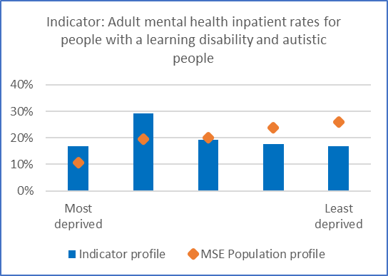Graph 1 shows Adult mental health inpatient rates for people with a learning disability and autistic people by deprivation quintile, comparing the indicator profile against the MSE population profile, with quintile 1 (most deprived) being 16.9% compared to 10.6%, quintile 2 being 29.2% compared to 19.6%, quintile 3 being 19.2% compared to 20%, quintile 4 being 17.7% compared to 23.7% and lastly quintile 5 (least deprived) being 16.9% compared to the MSE population of 26%.

Graph 2:  Adult mental health inpatient rates for people with a learning disability and autistic people – performance by ethnicity

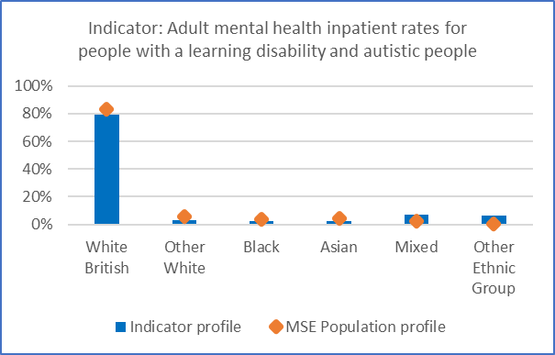Graph 2 shows Adult mental health inpatient rates for people with a learning disability and autistic people by ethnic group, comparing the indicator profile against the MSE population profile, with white British being 79.2% compared to 83.21%, other white being 3.1% compared to 5.76%, black being 2.3% compared to 3.76%, Asian being 2.3% compared to 4.18%, mixed being 6.9% compared to 2.34% and lastly other ethnic group being 6.2% compared to the MSE population of 0.75%.

Graph 3:  Adult mental health inpatient rates for people with a learning disability and autistic people – performance by gender

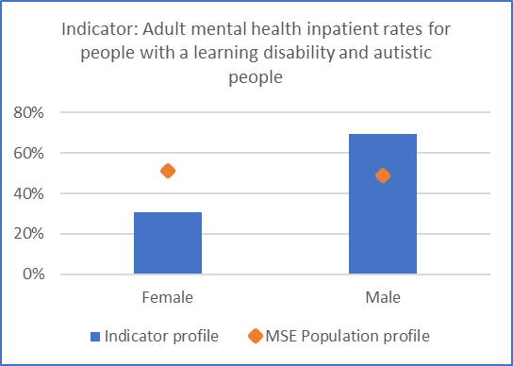Graph 3 shows Adult mental health inpatient rates for people with a learning disability and autistic people by gender, comparing the indicator profile against the MSE population profile, with female being 30.8% compared to 51.2% and male being 69.2% compared to the MSE population of 48.8%.

Graph 3:  Adult mental health inpatient rates for people with a learning disability and autistic people – performance by age

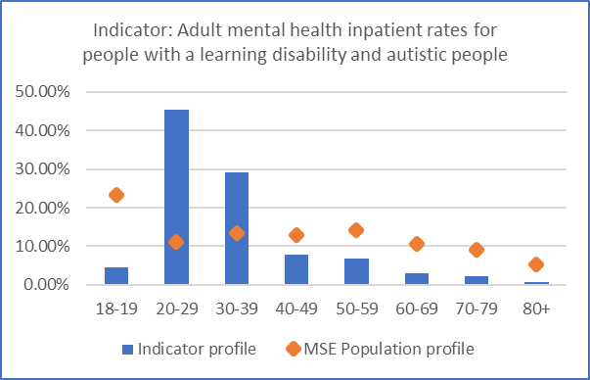Graph 4 Adult mental health inpatient rates for people with a learning disability and autistic people by age, comparing the indicator profile against the MSE population profile, with age range 0-19 being 4.6% compared to 23.4%, 20-29 being 45.4% compared to 11.2%, 30-39 being 29.2% compared to 13.3%, 40-49 being 7.7% compared to 13%, 50-59 being 6.9% compared to 14%, 60-69 being 3.1% compared to 10.7%, 70-79 being 2.3% compared to 9.2% and lastly 80 and over being 0.8%, compared to the MSE population of 5.2%.

**Observed health inequalities**

* Higher mental health inpatient rates for people with learning disability and autistic people are seen in the areas of greater deprivation
* The profile of adult mental inpatient rates is broadly in line with the ethnic profile of MSE population
* A greater proportion of admissions are Males
* The age profile is concentrated in the 20 to 39 year age group
* The high proportion of 18-19 year olds represents predominantly Autistic young people transitioning to adult services.
* Lack of specialist providers can lead to avoidable Adult Mental Health admission to inpatient services.

**Action is being taken to address these health inequalities**

* The creation of a new Dynamic Support Register which launched at the end of 2023 will help to identify those that need support before they become at risk of admission and / or enter a crisis.
* Work is ongoing to establish better links between Mental Health Services and Learning Disability services and Autistic people services.
* Wider work into preventing avoidable admissions is also taking place alongside case management of those at risk of admission.

*Source: Mental Health Services Data Set*

## Domain: Maternity and neonatal

**Indicator:** **Preterm births under 37 weeks**

Graph 1:  Preterm births under 37 weeks – performance by deprivation by quintile

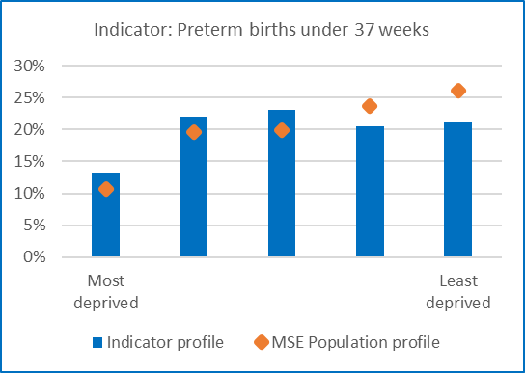Graph 1 shows Preterm births under 37 weeks by deprivation quintile, comparing the indicator profile against the MSE population profile, with quintile 1 (most deprived) being 13.2% compared to 10.6%, quintile 2 being 22% compared to 19.6%, quintile 3 being 23.1% compared to 20%, quintile 4 being 20.5% compared to 23.7% and lastly quintile 5 (least deprived) being 21.2% compared to the MSE population of 26%.

Graph 2:  Preterm births under 37 weeks – performance by ethnic group

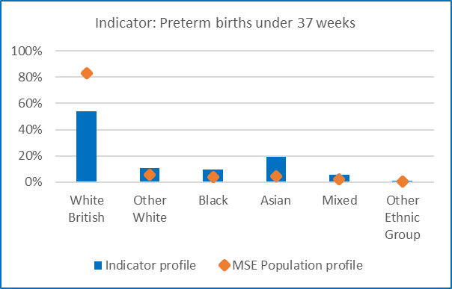Graph 2 shows Preterm births under 37 weeks by ethnic group, comparing the indicator profile against the MSE population profile, with white British being 54% compared to 83.21%, other white being 10.7% compared to 5.76%, black being 9.4% compared to 3.76%, Asian being 19.4% compared to 4.18%, mixed being 5.5% compared to 2.34% and lastly other ethnic group being 0.9% compared to the MSE population of 0.75%.

Graph 3:  Preterm births under 37 weeks – performance by age

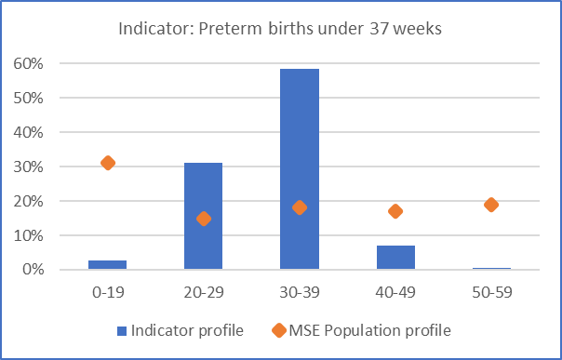Graph 3 shows Preterm births under 37 weeks by age, comparing the indicator profile against the MSE population profile, with age range 0-19 being 2.7% compared to 31%, 20-29 being 31.1% compared to 15%, 30-39 being 58.6% compared to 18%, 40-49 being 7% compared to 17%, and lastly 50-59 being 0.6% compared to the MSE population of 19%.

**Observed health inequalities**

* In MSE after White British women, Asian women experience the highest rate of preterm births (19.4%). This group observed the largest percentage increase in preterm births in 2020-21 nationally (ONS, 2023).
* The MSE data reflects a variation from national statistics, where women from Black ethnic groups have the highest proportion of preterm births.
* Deprivation data shows that the 2nd and 3rd quintiles of deprivation have the highest rates of preterm birth.
* The age range where preterm birth occurs most frequently is shown here as 30-39 and this is likely to be attributed to this age group because they have the highest proportion of births.

**Action being taken to address these health inequalities**

* Implementation of the Saving Babies Lives Care Bundle version 3
* Provision of a Preterm Birth Lead Team at every maternity site
* Patient Information Leaflet created – highlighting risks including ethnicity and age
* Preterm Birth Risk Assessment is undertaken at every maternity booking appointment
* Introduction of a preterm birth digital tool – QUiPP app to improve prediction and care of those who may be in preterm labour
* A Smoke Free Pathway has been launched in maternity services
* A Maternal Medicine pathway to support those with complex pregnancies
* Continuity of Midwifery Care Team at Broomfield Hospital – targeted to areas of deprivation and ethnicity
* Where preterm birth is anticipated – the PERIPrem care bundle is used to optimise the baby’s wellbeing.

*Source: MSE local dataset – Athena*