Get support: a quick reference guide

## Introduction

### Purpose of the guide

### This guide explains show users how to access the get support screen to view the support routes.

### Target audience

Anyone who uses the Shared Care Record.

### Prerequisites and requirements

Access to Shared Care Record with an individual’s record open.

***Please note that the record shown is a test patient and does not contain any personal identifiable information.***

## Step-by-step instructions

### Select the get support from the clinical document viewer tree within the person summary tab.

**

### This will show the following support information:

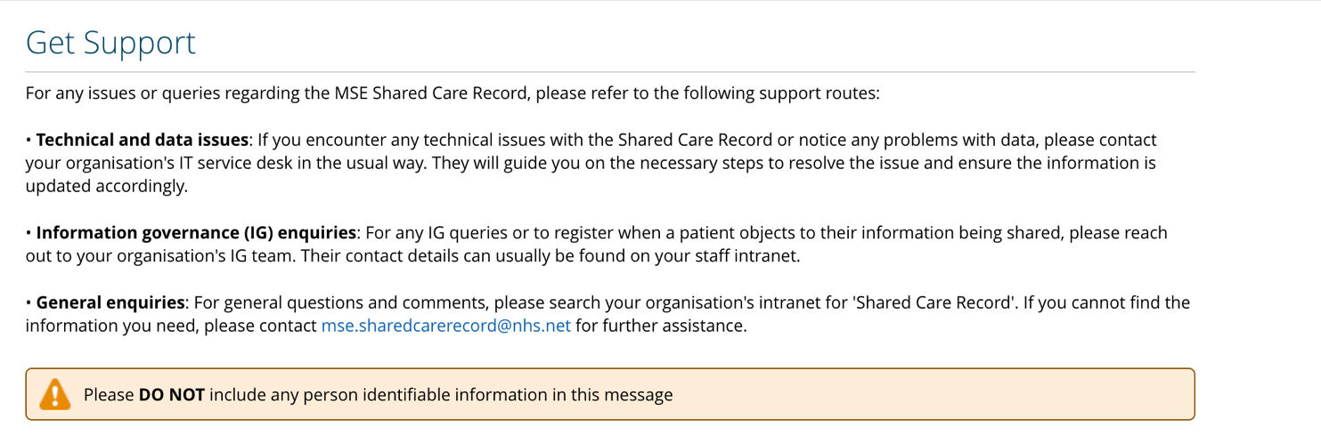

### Selecting the understanding this data button will open a page on the MSE ICS website that contains a data visibility guide. It also has guidance on using the information in the Shared Care Record safely and effectively.

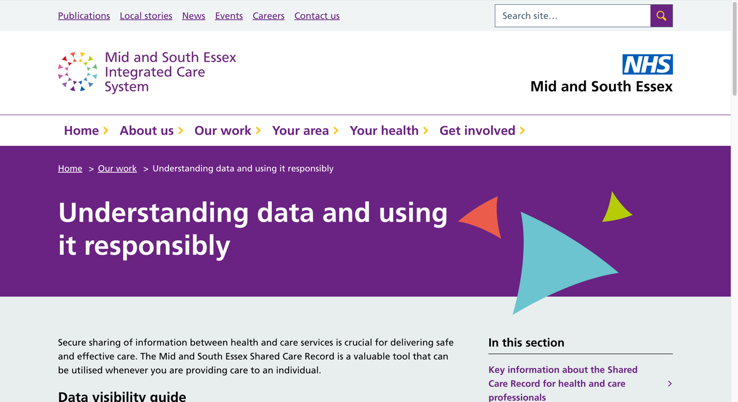

### Selecting the training and key information button will open a page on the MSE ICS website that contains key Shared Care Record resources for health and social care professionals.

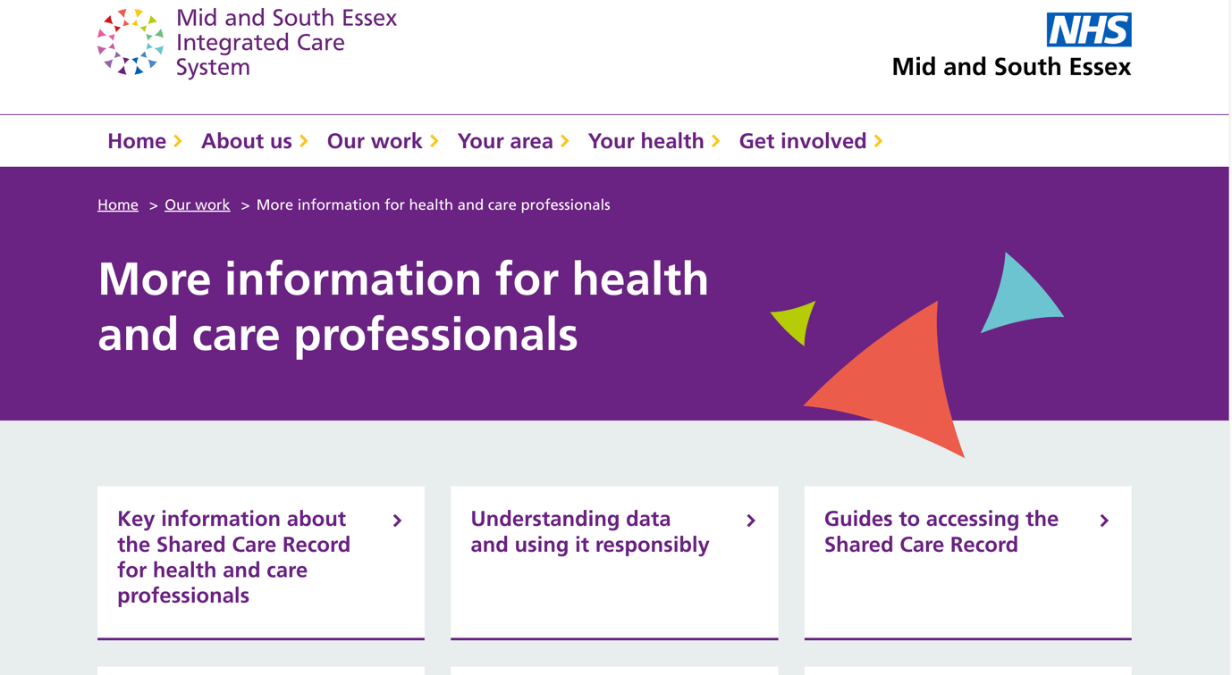

## Additional resources

* **Further information:** <https://midandsouthessex.ics.nhs.uk/sharedcarerecord>
* **Contact information for feedback:** [mse.sharedcarerecord@nhs.net](mailto:mse.sharedcarerecord@nhs.net)